ADEP V5
TECHNICAL SPECIFICATIONS

Version: 1.0.12
Date created: 17/11/2006
Date modified: 17/06/2026

Table of contents
I. Introduction 5
1. General presentation of ADEP 5
2. Release notes 5
3. Glossary 5
II. Technical Presentation 6
1. Technology used 6
2. Architecture 6
3. Sequence diagram 7
III. ACCESS 7
1. Production Environment 7
2. Test Environment 7
3. Recommendations 7
4. International Standards 8
4.1 HR-XML 8
4.2. ISO 9
IV. Authentication 9
V. MANAGEMENT OF IDENTIFIERS 11
VI. TRANSACTION MANAGEMENT 12
1. Transaction identification 12
2. Acknowledgement of transactions 13
2.1 Description 13
2.2 Example 14
VII. Offer Module 15
1. Presentation 15
2. General description of the Module 15
2.1 Reminder of the general principles of ADEP 15
2.2 General use case diagram 16
2.4 List of Web Services linked to the Offer Module 18
VIII. Life cycle of an offer 20
1. Status diagram of an offer 20
IX. DESCRIPTION OF SERVICES 21
1. Create an offer 21
1.1 Detailed description 21
1.2 Input data 22
1.3 Output data 23
1.4 SEP and SIDES format 23
2. Modify an offer 23
3. List offers from a recruiter 24
3.1 Detailed description 24
3.2 Input data 24
3.3 Output data 25
4. Obtain the status of an offer 25
4.1 Detailed description 25
4.2 Input data 25
4.3 Output data 26
5. Change the status of an offer 26
5.1 Detailed description 26
5.2 Input data 27
5.3 Output data 29
6. Get an offer 29
6.1 Detailed description 29
6.2 Input data 29
6.3 Output data 30
X. Elements and types of SEP module 31
1. The PositionOpeningType type 31
1.1 PositionSupplier element 31
1.2 PositionProfile element 33
1.3 Organization element 35
1.4 PositionDetail element 36
1.5 FormattedPositionDescription element 39
1.6 IndustryCodeType element 41
1.7 PhysicalLocation element 41
1.8 RemunerationPackage element 43
XI. ELEMENTS AND TYPES OF SIDES MODULE 45
1. The SidesPositionOpeningType type 45
1.1 staffingOrder element 45
1.2 onBehalfOf element 56
XII. HR-XML CPO ELEMENTS AND TYPES (COMMON TO SEP AND SIDES) 57
1. The PersonNameType type 57
2. The PostalAddressType type 58
3.The CompetencyType type 60
4. The OrganizationType type 62
4.1 ContactInfo element 64
4.2 IndustryCode element 66
5 OpenPositionResponseType element 66
5.1 OnePositionType element 66
6 EducationType element 66
XIII. Internship Offer 67
1. Contract Type 67
2. Education Level 67
3. Job Type 68
4. Displayed Pay 68
5. Experience Level 68
6. Minimum Salary 68
7. Maximum Salary 68
8. Offer Type 68
9. Contract Duration 68

I. Introduction

1. General presentation of ADEP

ADEP aims to simplify recruitment management for Apec's clients. Most recruitment managers use a dedicated in-house Human Resources Information System (HRIS), which means they have to keep the website https://www.apec.fr and their HRIS up-to-date.

Thanks to the ADEP application, it is possible to communicate with APEC using a library of functions (service calls) similar to that offered by the site https://www.apec.fr without using the site itself. Everything is done "transparently", using Web Services/SOAP in conjunction with the format produced by the international HR-XML (Human Resources XML) standard.

ADEP complies with the two standards produced by the HR-XML consortium: SIDES and SEP. This openness makes ADEP a key player for companies with substantial recruitment needs.

2. Release notes
Version | Description
3.1 | Not compatible with version 3.0
4.0 | Not compatible with version 3.1
5.0 | Not compatible with version 4.0

3. Glossary
ADEP | Apec Data Exchange Protocol
Web Services | Web Services 2.0
 | https://www.w3.org/TR/wsdl20/
WSDL | Web Services Description Language. Describes a Public Interface
 | for accessing one or more Web Services. This is an XML-based
 | description that indicates "how to communicate to use the service"; the
 | communication protocol, and the message format required to
 | communicate with this service. The possible operations and messages
 | are described in an abstract way, but this description refers to
 | concrete network protocols and message formats.
SOAP | Simple Object Access Protocol. Object-oriented RPC protocol based on
 | XML. It allows messages to be transmitted between remote objects, which
 | means that it allows an object to invoke the methods of
 | objects physically located on another machine.
 | SOAP 1.2
 | https://www.w3.org/2000/xp/Group/
HR-XML | HR-XML is an independent, not-for-profit consortium which aims to
 | promote e-commerce and the exchange of data relating to
 | human resources management at a global level, in particular through the
 | promotion of standard XML vocabulary in human resources
 | management. HR-XML has produced 2 recruitment standards: SEP
 | and SIDES.
SEP | The Staffing Exchange Protocol (SEP) is a set of XML specifications
 | supporting many types of transactions geared towards
 | recruitment and, to a lesser extent, temporary work. The
 | transactions supported by this protocol include the publication of job
 | offers and the exchange of CVs and/or candidate profiles.
 | https://www.hropenstandards.org/
SIDES | The Staffing Industry Data Exchange Standards (SIDES) are made up of
 | XML schemas for exchanging data between temporary employment
 | companies, their intermediaries and end customers.
 | https://www.hropenstandards.org/
CPO | Cross Process Objects: designates the common HR-XML modules used
 | by both SEP and SIDES.
 | https://www.hropenstandards.org/
SHA512 | Sha-512 (Secure Hash Algorithm) is a function of the Sha-2 cryptographic algorithm, an evolution of Sha-1. It is similar to its counterpart, Sha-256, except that it uses 1024-bit 'blocks', accepts as input a message with a (theoretical) maximum of 2^128 bits and produces a result (called a 'hash', condensate or fingerprint...) of fixed size. The size of the hash is indicated by the suffix: 224 bits for SHA-224, 256 bits for SHA-256, 384 bits for SHA-384 and 512 bits for SHA-512.
RPC | Remote Procedure Call. Protocol for making procedure
 | calls on a remote computer using an application server.
 | This protocol is used in the client-server model to manage
 | the various messages between these entities.
Acknowledgement | Response message sent by the ADEP web service indicating the status of the
 | successful call to the web service. A Fatal error will indicate
 | an error preventing the service from being completed.
Domain | Domains are sets of admissible values for an
 | HR-XML field. The Apec fields are: CIVILITE_DOMAIN,
 | STATUT_OFFRE_DOMAIN... For more information about domains,
 | you can refer to the documents in the "Domains" directory
 | of the Technical Package.
ODD | ODD = DOMICILED DIRECT CLIENT OFFER Applications are
 | sent directly to the recruiter without any intervention from Apec. ODD
 | is the default status of offers in the Apec IS.
 | By default, the offer is the ODD type.
ODC | ODC = CONFIDENTIAL DIRECT OFFER. The client is not visible,
 | i.e. the company name and logo do not appear and
 | it is impossible to enter an application url.


II. Technical Presentation

1. Technology used

ADEP services are accessed using Web Services defined by a single interface made available to clients: the WSDL document. The messages sent and received by ADEP are made up of the XML structures indicated in the WSDL and encapsulated in the SOAP message format, an extension of XML. These messages are sent using the HTTP protocol.

The data structures defined in the WSDL are based on the HR-XML standard, an international standard for the standardisation of HR data exchanges and should make transactions between ADEP and the Client HRIS more fluid.

Web Services are easy to use thanks to a clear interface, they are widely documented and are considered to be the standard for data exchange. They also have the advantage of being completely independent of the technical platform used to access services, thanks to SOAP's XML format.

2. Architecture
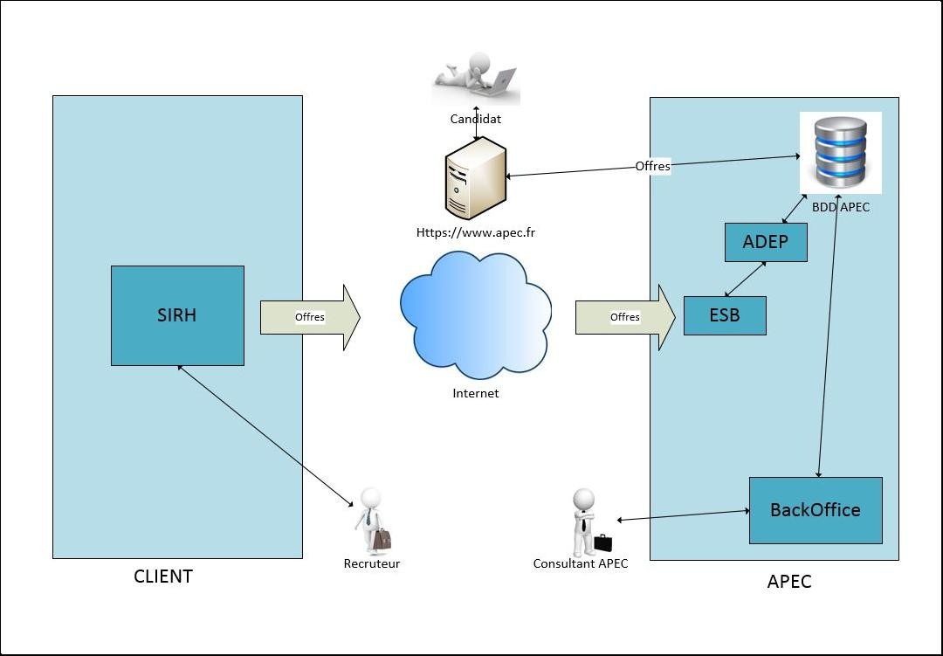

Candidate
Offers

APEC DATABASE
ADEP
Https://www.apec.fr

ESB
HRIS
Offers
Offers

Internet

CLIENT
APEC Consultant
Recruiter
BackOffice
APEC

3. Sequence diagram

Here is the sequence diagram for creating an offer:
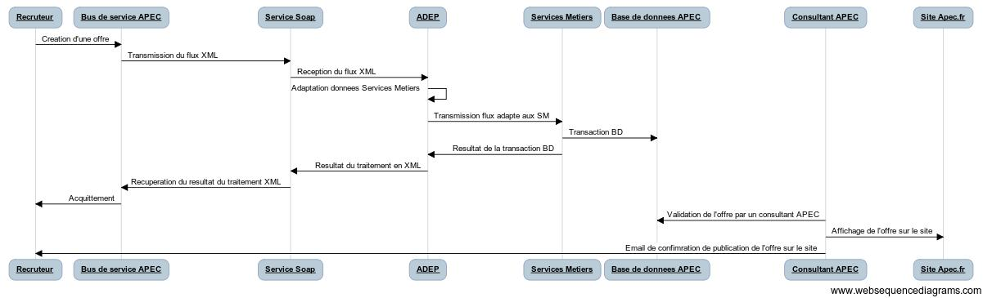
ADEP
Soap service
APEC Consultant
APEC database
Business Services
Apec.fr website
Business Services
Apec.fr website
APEC service bus
Recruiter
Receiving the XML flow
Creating an offer
Transmission of XML flow
Transmission of adapted flow to SM
Adaptation of Business Services data
DB transaction result
XML processing result
DB transaction
Validation of the offer by an APEC consultant
Retrieving the result of XML processing
Acknowledgement
Posting the offer on the site
Email to continue publication of the offer on the site
APEC Consultant
APEC database
Soap service
ADEP
Recruiter
APEC service bus
www.websequencediagrams.com

All messages are synchronised, although some tasks may be desynchronised, such as validation of the offer by the APEC consultant. Each Web Service call returns an acknowledgement. This is detailed later in the document.

III. ACCESS

1. Production Environment

The ADEP v5 production environment is:

Production ADEP V5 / HR-XML SEP

https://adepsep.apec.fr/v5/positions?wsdl

Production ADEP V5 / HR-XML SIDES

https://adepsides.apec.fr/v5/positions?wsdl

2. Test Environment

We can also provide you with a test environment for setting up your ADEP interface. This client integration environment can be found at the following address:

ADEP V5 / HR-XML SEP test

https://testadepsep.apec.fr/v5/positions?wsdl

ADEP V5 / HR-XML SIDES test

https://testadepsides.apec.fr/v5/positions?wsdl

3. Recommendations

Character encoding:

We use UTF-8 encoding. To preserve accents and other special characters. We recommend that you use the same encoding standard in your interface.

Java library:

ADEP is written in Java and we recommend using JAX-WS 2.0 if you are also developing your interface in Java. In the case of development in Java, we also provide an example of Java code for creating an offer.

Implementation of the HR-XML standard:

To facilitate integration with ADEP, we recommend that you carefully respect the HR-XML structures and Apec domains .

4. International Standards

4.1 HR-XML

The ADEP V2 / HR-XML SEP and ADEP V2 / HR-XML SIDES applications make extensive use of the data structures published by the HR-XML consortium ( http://hrxml.org).

However, the XSD schemas are not directly available on the HR-XML consortium website

4.2. ISO

4.2.1 Countries, French regions and departments

Countries, French regions and departments will be indicated according to their ISO 3166-2 code.

https://en.wikipedia.org/wiki/ISO_3166-2:FR
It is important to note that only ISO 3166-2 codes for French regions and departments are currently authorised. Using ISO 3166-2 codes for other countries will result in a service error.

Overseas regions and departments, French territorial collectivities and overseas territories have both their own region code (ISO 3166-2) and country code (ISO 3166-1) (which are sometimes identical). They can be entered either as French regions (ISO 3166-2 code) or as "countries" (ISO 3166-1 code).

4.2.2 Dates

Dates will be indicated in the formats proposed by the ISO 8601 standard.

Two of the formats defined in this standard are also adopted by the XML Schema specification (XSD):

Dates without a time will be expressed in "current date" format:
NB: Format AAAA-MM-JJ+HH:00 can be used but the part +xx:00 will not be used.

YYYY-MM-DD. This ISO format corresponds to the XSD "date" type.

Dates with times (timestamps) will be expressed in "date and time" format:
YYYY-MM-DDThh:mm:ss[Z|(+|-)hh:mm]. This ISO format corresponds to the XSD "dateTime" format.

NB: note the capital 'T' to separate the date from the time.

4.2.3 Languages

Languages will be indicated according to their ISO 639-1 code (2 characters). https://www.loc.gov/standards/iso639-2/php/code_list.php

It should be noted, however, that ADEP currently only accepts French (code "fr").

4.2.4 Currencies

Currencies will be indicated according to their ISO 4217 code (3 characters).

It should be noted, however, that ADEP currently only accepts currencies expressed in euros (code "EUR").

IV. Authentication

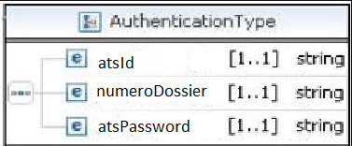

<authentication>
<atsId>26</atsId>
<numeroDossier>100248886W</numeroDossier>
<atsPassword>6e32e237a86339190512f1153d655962e8b7ad8fb8ccae70eeef737c3b94672fac555ba808fd2619babdc5c6926be5c2b639dcad3c03816eb53086132a6f5128</atsPassword>
</authentication>

All ADEP services require an authentication parameter as input, usually called authentication. This structure, the AuthenticationType, has the following components:
Element | Description | Data format
atsId | The ATS identifier provided by Apec to ATS  EX: 50 | Character string
numeroDossier | Identifier of the contact person (or recruiter) provided by Apec.  EX : 13456789W | Character string
atsPassword | Argon2 key for authentication. Generated by ATS from reinitialization mail sent by the adep support | Character string

We are currently using Argon2, an algorithm designed for secure password hashing. It was created to resist brute-force attacks.

The algorithm takes into account several configurable parameters:

- The password (initial secret)
- The salt to ensure uniqueness
- The allocated memory
- The version used
- The number of iterations (time cost)
- The degree of parallelism (number of threads)
- The type of Argon2 variant to use (i, d, or id). We are currently using argon2id, optimized for passwords.

For more information on Argon2 hashing components: https://en.wikipedia.org/wiki/Argon2

Generation of your Argon2 key:

Your Argon2 key is generated from the chosen password, combined with salt, and the Argon2 parameters received by email in the form of a table with the following structure.

Element | Data format
Degree of parallelism | Integer
Number of iterations | Integer
Salt | String

The other Argon2 parameters are not transmitted, as they are defined as constants:
- Argon2 variant: Argon2id
- Allocated memory: 4096
- Version: 19

Code snippet to generate your Argon2 key:

The hashing function uses the salt and Argon2 parameters as arguments to produce the encrypted password:

hashedPassword = encryptArgon2Function(password, salt, iterations, parallelism)

Java(Argon2BytesGenerator):

import org.bouncycastle.crypto.generators.Argon2BytesGenerator;
import org.bouncycastle.crypto.params.Argon2Parameters;
public static String encryptArgon2Function(String password, String salt, int iteration, int parallelism) {
Base64.Decoder b64decoder = Base64.getDecoder();
Base64.Encoder b64encoder = Base64.getEncoder().withoutPadding() ;
int memory = 4096;
int version = 19;
try {
Argon2Parameters argon2Parameters = new Argon2Parameters
.Builder(Argon2Parameters.ARGON2_id)
.withVersion(version)
.withMemoryAsKB(memory)
.withIterations(iteration)
.withParallelism(parallelism)
.withSalt(b64decoder.decode(salt))
.build();
// Création du générateur Argon2
Argon2BytesGenerator generator = new Argon2BytesGenerator();
generator.init(argon2Parameters);
// Génération du hash
byte[] result = new byte[256]; // 32 bytes = 256 bits
generator.generateBytes(password.toCharArray(), result);
// Conversion en hexadécimal
return b64encoder.encodeToString(result);
} catch (Exception e) {
throw new RuntimeException("Erreur lors du hachage avec Argon2", e);
}
}

Python (with argon2-cffi):
import argon2.low_level as argon2_low_level
import base64
def encryptArgon2Function(password, salt, memory, iteration, parallelism):
salt_padded = salt + "=" * ((4 - len(salt) % 4) % 4)
try:
salt_bytes = base64.b64decode(salt_padded)
except Exception as e:
print(f"Error decoding salt: {e}")
return None
# Génération du hash
raw_hash = argon2_low_level.hash_secret_raw(
secret=password.encode('utf-8'),
salt=salt_bytes,
time_cost=iteration,
memory_cost=memory,
parallelism=parallelism,
hash_len=256,
type=argon2_low_level.Type.ID
)
# Conversion en hexadécimal
return base64.b64encode(raw_hash).decode('utf-8').rstrip('=')

Process of creating multi-broadcasters:

When signing the ADEP contract between a multi-broadcaster and Apec, the multi-broadcaster provides Apec with the following contact information: email address, first name and last name.
Then:
- Apec sends an email to this contact to invite them to create a password.
- Once the password is set, a second email is sent containing (as shown in the example above):
• The salt
• The Argon2 configuration parameters
These elements allow the multi-broadcaster to generate a hashed password with Argon2, required to authenticate and interact with the ADEP API.

V. MANAGEMENT OF IDENTIFIERS
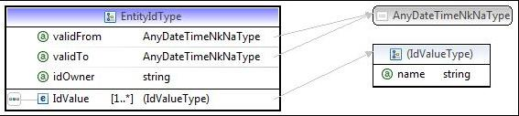

The exchange of identifiers between the client and Apec HRIS systems is standardised. ADEP uses an ad hoc structure for this purpose: EntityIdType, taken from the HR-XML CPO standard.

Wherever possible, any identifier (transaction identifier, offer identifier, partner identifier, etc.) should be encapsulated by the EntityIdType type, with the following ADEP-specific remarks:
Element | Description | ADEP processing | Format
validFrom |  | Ignored
validTo |  | Ignored
idOwner | Owner of | Required | If the owner is the "CLIENT"
 |  |  | If the owner is Apec: "APEC”
 | the identifier |  | If the owner is INSEE (this is the case when the identifier
 |  |  | to be provided is the SIRET number): "INSEE”
 |  |  | If the owner is ISO (for languages and
 |  |  | locations): "ISO"
IdValue | Identifier | Required, only one | Variable, depending on the nature of the identifier to be
 |  | authorised | provided
name | Name | Optional

VI. TRANSACTION MANAGEMENT

1. Transaction identification

Each client request must be identified by a unique payload tracking id.

The transaction identifier must be generated by the client, and the client must send a different value for each request.

In principle, this value must be unique within the client's HRIS for each new request, so that the client can identify the transactions separately.

This identifier is required by all ADEP services, usually via a parameter named uniquePayloadTrackingId. However, ADEP does not store this information; it is only used to return a transaction acknowledgement to the client (see 2 below).

The identifier must be transmitted in the form of an HR-XML CPO EntityIdType structure, as described in Chapter V above.

ADEP accepts any alphanumeric identifier containing up to 100 characters.
However, certain characters are prohibited in a transaction identifier. These characters are as follows:
?|,=<>:"[]\/(){}!;'`@#$~+*&^

Similarly, the so-called control characters (unicode: 00 to 1F and 7F to 9F) are also prohibited.

To sum up, we strongly recommend that you use a timestamp corresponding to the time at which the request was sent
concatenated with your Adep partner ID:

Example:
IdPartner-Timestamp

This would give, for example, a valid transaction identifier such as the following:
006-1162513918309

2. Acknowledgement of transactions

2.1 Description

In response, many ADEP Web Services return a transaction acknowledgement indicating any errors encountered when processing the client request.

The acknowledgement is returned in the form of an AcknowledgeType element. This type is derived from the HR-XML CPO standard.
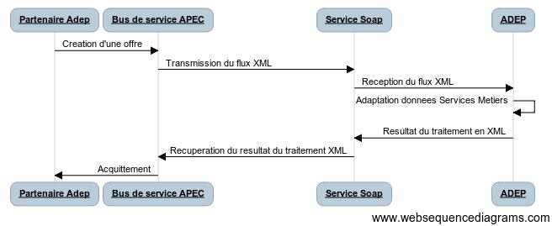
APEC service bus
Adep partner
Soap service
ADEP
Creating an offer

Transmitting the XML flow
Receiving the XML flow

Adaptation of Business Services data

XML processing result

Retrieving the result of XML processing
Acknowledgement

APEC service bus
Adep partner
ADEP
Soap service

www.websequencediagrams.com

The use of this type in ADEP is described in detail in the document Catalogue of errors - ADEP V5.pdf, which can be found in the Specifications folder.

This element can be interpreted directly by the IS calling ADEP or simply read by the user receiving the response.

The two main pieces of information to remember are contained in the following tags:

<EntityNoException>: This tag is the main indicator that a call to an ADEP web service has been successfully completed. If it is present, the information contained will be "true", i.e. everything went well. On the other hand, if it is not present for a given entity, the next tag should be consulted.
<EntityException>: this tag will contain the description of the various pieces of information that the web service has seen fit to return to the user. The 2 most important pieces of information to consult are:* <ExceptionSeverity>: This tag will contain the severity indicator for the exception that has occurred. There are three levels of severity:
Informational, Warning and Fatal. The first 2 are used to flag non-blocking exceptions to the web service call (for example to warn that a non-mandatory field is empty). On the other hand, a Fatal error level will stop the web service, and an error code will be attached to this exception. This can happen, for example, when a mandatory field is not provided.

<ExceptionMessage> : this tag will contain the name and code of the error encountered, you should then refer to Catalogue of errors - ADEP V2.pdf, for a full description of the error, and the start of a path for correcting the anomaly.

2.2 Example

We will not reproduce the entire acknowledgement here but will isolate the interesting parts. A more detailed description of the acknowledgement fields can be found in the Catalogue of errors - ADEP V2.pdf.

?xml version="1.0" ?>

<S:Envelope xmlns:S="http://schemas.xmlsoap.org/soap/envelope/"> <S:Body><ns2:openPositionResponse xmlns="http://ns.hr-xml.org/2006-02-28" xmlns:ns2= "http://adep.apec.fr/hrxml/sides">

<PayloadResponseSummary> <UniquePayloadTrackingId idOwner="CLIENT"> <IdValue>ADEPTEST-011-1197903273800</IdValue> </UniquePayloadTrackingId>

<TransactionReceiptTimestamp>2007-12-17T15:55:02.475+01:00</TransactionReceiptTimestamp> <AcknowledgementCreationTimestamp>2007-12-17T15:55:48.369+01:00</AcknowledgementCreationTimestamp> <ReceivedPayloadSummary>

[…]

<EntityDisposition> <EntityIdentifier idOwner="UNKNOWN"> <IdValue>fr</IdValue> </EntityIdentifier>

<EntityShortName>Order Language</EntityShortName> <EntityInstanceXPath>//position/staffingOrder/@xml:lang</EntityInstanceXPath> <EntityNoException>true</EntityNoException>

</EntityDisposition>

In this part of the dispatch, we can see that for the "Order Language" entity, everything went well.
[…]

<EntityDisposition> <EntityIdentifier idOwner="UNKNOWN"> <IdValue>CDI</IdValue> </EntityIdentifier>

<EntityShortName>Position Type</EntityShortName> <EntityInstanceXPath>

//position/staffingOrder/StaffingPosition/PositionHeader/PositionType</EntityInstanceXPath> <EntityNoException>true</EntityNoException>

</EntityDisposition>

In this part of the dispatch, we can see that for the "Position Type" entity, everything went well.
[…]

<EntityDisposition> <EntityIdentifier idOwner="UNKNOWN">

<IdValue>TEST-1197903273925</IdValue> </EntityIdentifier>

<EntityShortName>Staffing Order</EntityShortName> <EntityInstanceXPath>//position/staffingOrder</EntityInstanceXPath> <EntityException>

<Exception>

<ExceptionIdentifier>330</ExceptionIdentifier>

<ExceptionSeverity>Fatal</ExceptionSeverity> <ExceptionMessage>API_330_CLIENT_INDIRECT_ACCESS_ERROR</ExceptionMessage> </Exception>

</EntityException>

</EntityDisposition>

In this part of the dispatch we can see that for the "Staffing Order" entity a problem has occurred, the severity is Fatal, so the call to the web service has failed.

The error reported is code 330 and corresponds to "Access refused in 'clientindirect' mode".

An acknowledgement containing for each entity <EntityNoException>true</EntityNoException>, or exceptions of severity less than Fatal will be considered successful. On the other hand, a "Fatal" exception will cancel any transaction carried out by the web service. If you want to analyse an acknowledgement correctly, you need to look for them first

VII. Offer Module

1. Presentation

The ADEP application has a service module for offers. This enables you to manage the entire life cycle of a job application on the "Recruiters" side. To help you understand how this module works, this document lists the various services and the parameters required for them to operate.
This document is intended to be as complete as possible so that the components can be used independently.

2. General description of the Module

2.1 Reminder of the general principles of ADEP

Adep is a software that enables dialogue between clients' HRIS and Apec's HRIS (SOCLE). Adep allows you to inject job offers from a client HRIS into SOCLE (offer module).

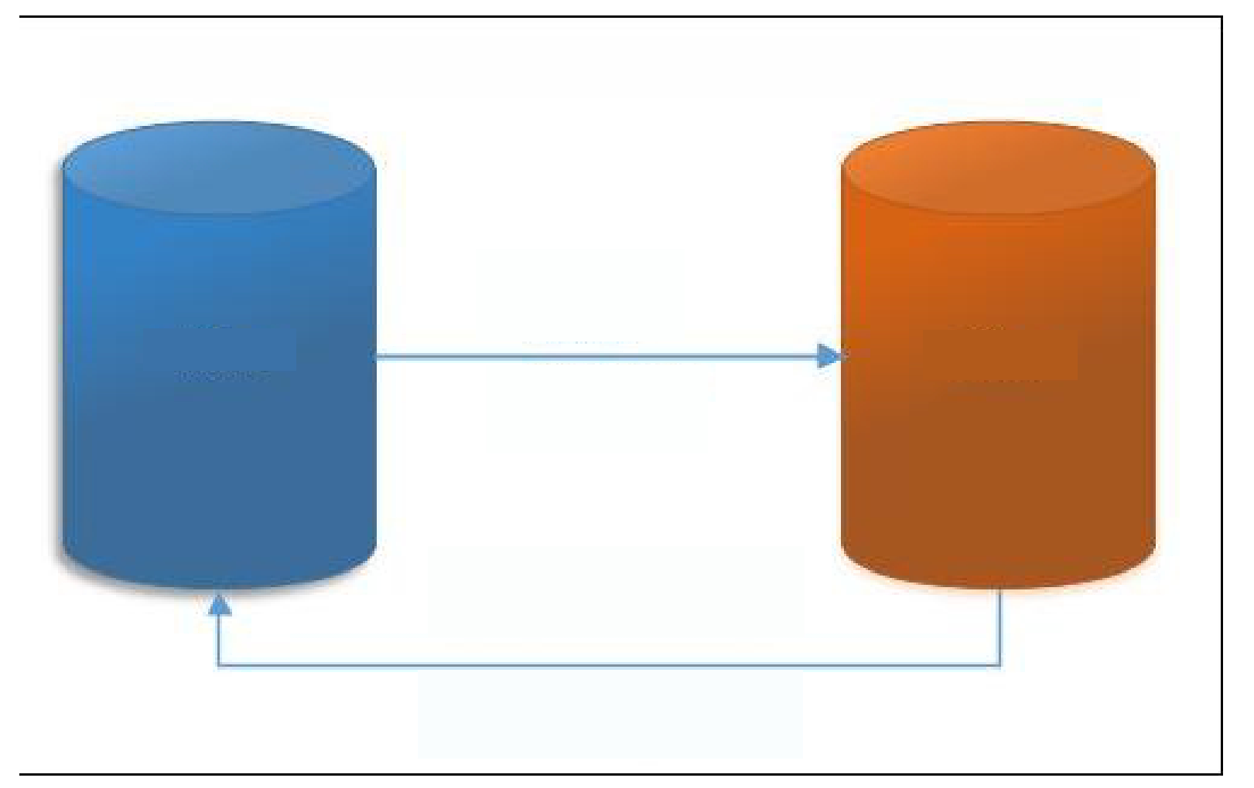

CLIENT HRIS
APEC HRIS

Creation
Modification
Offers
Offers

Retrieving offer status

Retrieving offers from a recruiter

2.2 General use case diagram
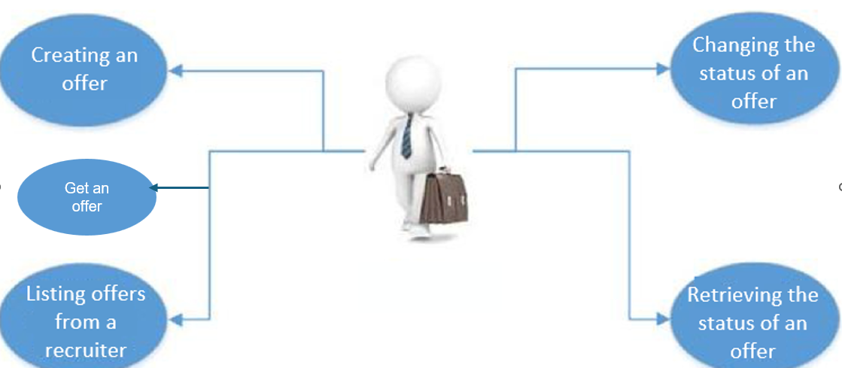

2.3 The Parties involved

The Client

This is the company or group that has subscribed to the ADEP service offer from Apec. This legal entity generally comprises several establishments and several recruiters who must subscribe to ADEP under the same partner ID, symbolising the grouping together under a single client.

There are 2 types of client:

Direct: those who recruit for their own staffing needs
Indirect: recruitment intermediaries who recruit on behalf of an actual client (e.g. temporary employment companies, IT services companies, etc.)
The Recruiter

This is a natural person working on behalf of the ADEP client. This person is responsible for managing job offers and sending them to ADEP. The recruiter is the recipient of the applications generated by the offer published on apec.fr.

The Apec Consultant

This is an individual who works for Apec. This person manages the job offers sent to the Apec business tool called CDM. Generally, applications are sent directly and automatically from Apec.fr to the client's HRIS.

2.4 List of Web Services linked to the Offer Module

The Web Services detailed in this document are extracted directly from the WSDL file (adepsep.wsdl or adepsides.wsdl depending on the data format chosen) provided in ADEP.

The following diagrams show the list of Web services in this module in both SEP and SIDES formats. They are generated from the WSDL files for each format.

2.4.1 SEP format

The Web Services in this module are:
- listRecruiterPositionsOpenings
- openPostion
- UpdatePosition
- updatePositionStatus
- getPosition
- getPositionStatus

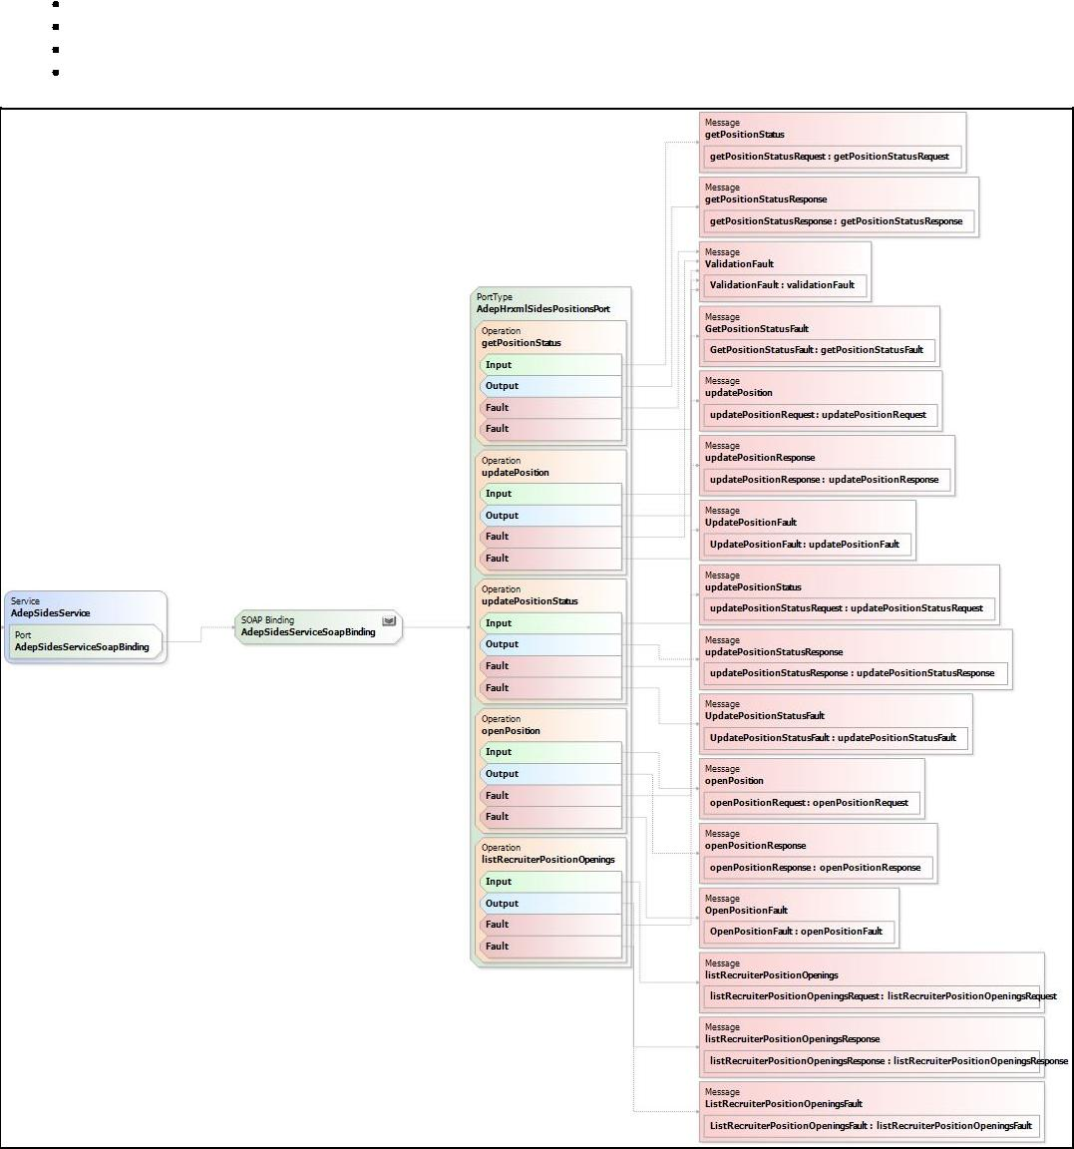

2.4.2 SIDES format

The Web Services in this module are:

- listRecruiterPositionOpenings
- openPostion
- UpdatePosition
- updatePositionStatus
- getPosition
- getPositionStatus

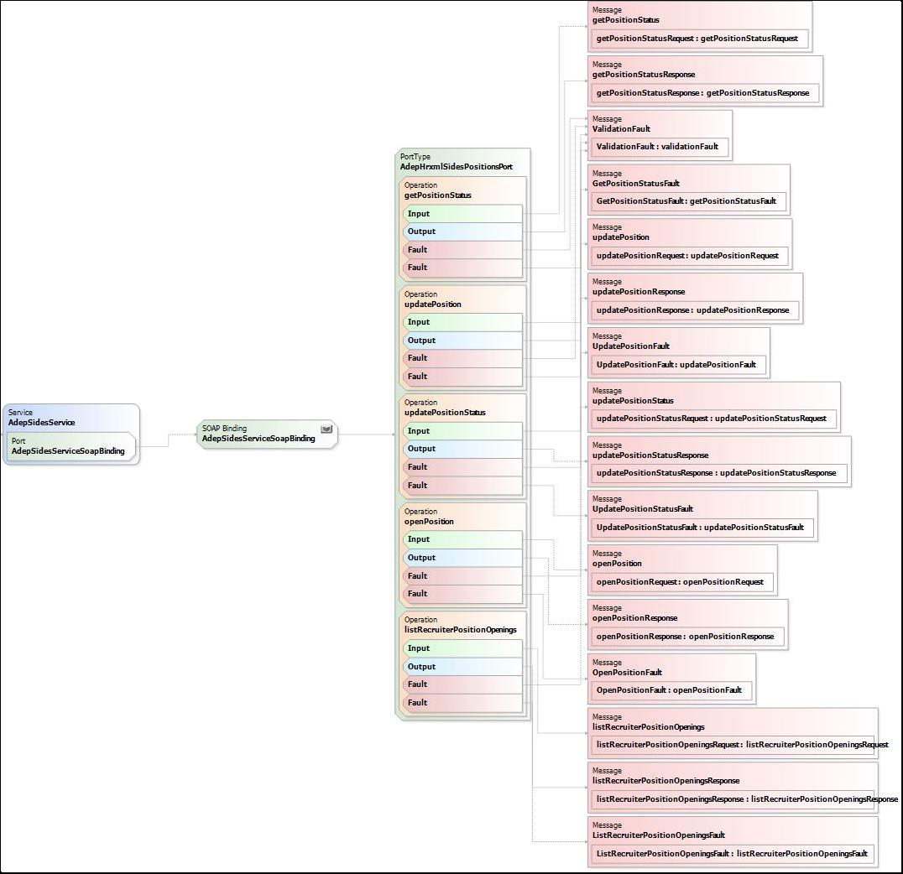

2.4.3 Service faults

For more information on error management, please refer to the document: dsiapec-ADEP - Catalogue des erreurs.pdf

VIII. Life cycle of an offer

1. Status diagram of an offer

The following diagram shows the different statuses that an offer can take in ADEP and the transitions between these statuses.
Retrieving the status of an offer
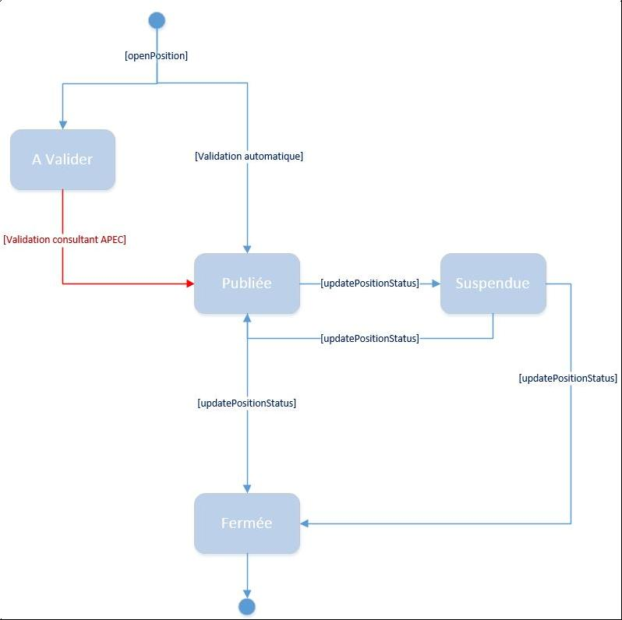

[openPosition]

To be Validated
[Automatic validation]

[APEC consultant validation]

Suspended
Published
[updatePositionStatus]

[updatePositionStatus]

[updatePositionStatus]
[updatePositionStatus]

Closed

The following table describes the possible actions depending on the status of an offer in ADEP.

ADEP statuses Possible actions

TO BE VALIDATED No action can be taken from this status in ADEP.
The reason may be that the offer was blocked by APEC
legal control or that the text of the offer does not contain
enough characters. Wait for a consultant from
Apec to validate the offer.

PUBLISHED The offer is published on the Apec website.
It can be modified via the www.apec.fr website or
by sending a request by email to supportadep@apec.fr

SUSPENDED The offer is no longer published but can be republished or closed.

CLOSED The offer is in terminal status. It is therefore no longer possible to change it.

IX. DESCRIPTION OF SERVICES

The SOAP flow sent to the service must contain specific data depending on the service requested.

This chapter describes each service in the Offers module and the data accepted as input and output by each of them.

1. Create an offer
This service enables you to create an offer within Apec's HRIS.

1.1 Detailed description

The main aim of entering offers via the ADEP application is to save recruiters’ time. This is because it is tedious to have to enter all the information pertaining to an offer when it has already been entered into the company's internal HRIS.

SEP Web Service | openPosition
SIDES Web Service | openPosition
Context of use | All recruiters who have subscribed to the service can enter a job offer.
Parties involved | Recruiter
Pre-conditions | Be an ADEP subscriber.
Description | An authorised recruiter can send an offer via this service. If the offer is validated, it joins the so-called traditional
offers,
 | i.e. those registered on the www.apec.fr website.
Exceptions | The recruiter is not recognised; not all the mandatory fields have been filled in for the offer...
Post-conditions | The offers received follow Apec's "traditional" life cycle. They are recorded in APEC’s
database,
 | validated by an Apec consultant.
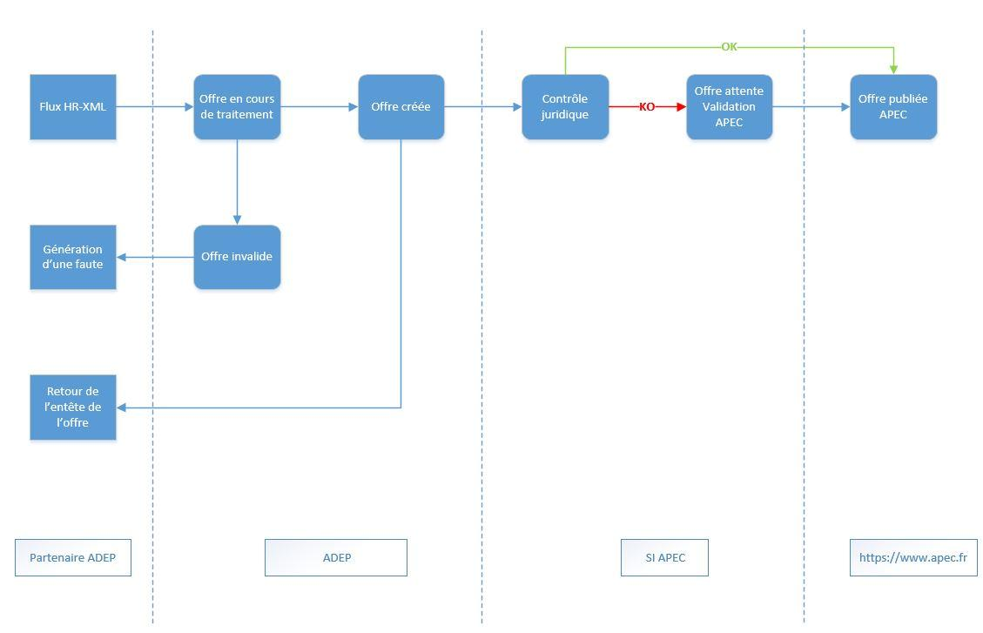
https://www.apec.fr
Back to the offer header
Legal control
Offer pending APEC validation
Offer awaiting publication by APEC
ADEP partner
ADEP
If APEC
OK
KO
Generating a fault
HR-XML flow
Offer invalid
Offer being processed
Offer created
Generating a fault

Offers entered via ADEP are recorded as “To be validated” if they have not passed our legal check. If this is not the case, the offer will be published directly on the site https://www.apec.fr without being validated by a consultant. If there is a problem, nothing is recorded and a service fault is returned. The offer thus registered will be integrated into the Apec IS and will no longer be linked to the partner offer. The consultant will be able to get in touch with the contact person and discuss any problems relating to his/her offer. Recruiters will be able to access job offers via the website https://www.apec.fr.

1.2 Input data

1.2.1 SEP format

The OpenPositionRequestType used in the SEP format is broken down as follows:
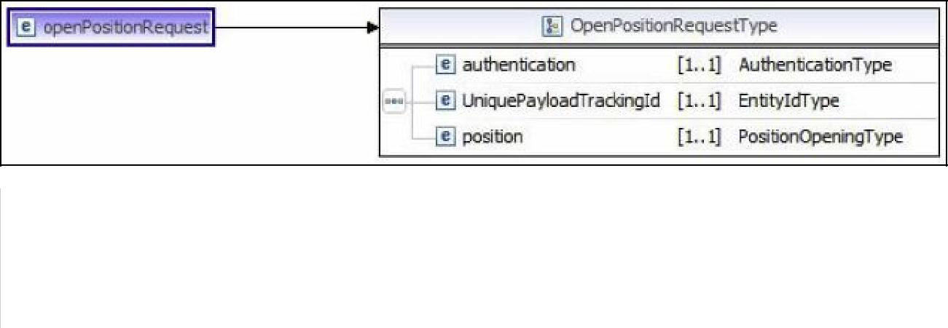

Parameter name | Type of parameter | Owner of the type | Description | ADEP processing | Remarks
authentication |  | ADEP | authentication data | required
 |  |  | from the ADEP client
uniquePayload-TrackingId |  | HR-XML CPO | transaction identifier | required
position |  | HR-XML SEP | the offer to be created | required

1.2.2 SIDES format

The OpenPositionRequestType used in the SIDES format is broken down as follows:
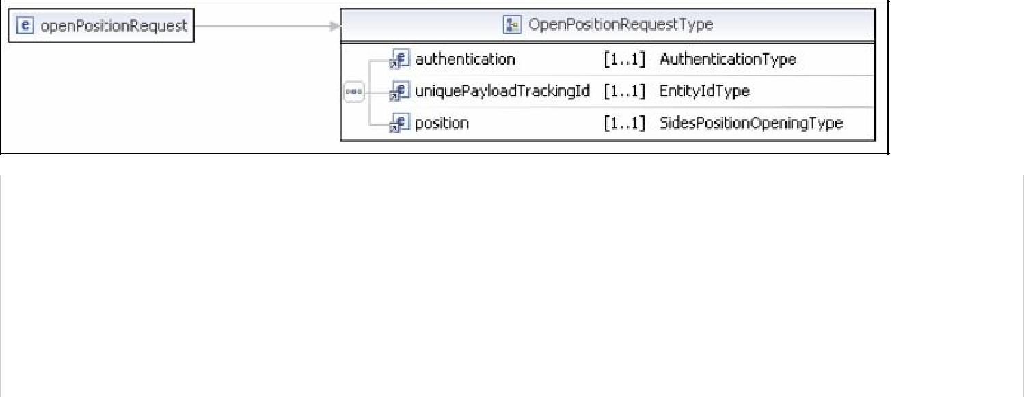

Parameter name | Type of parameter | Owner of the | Description | Processing | Remarks
 |  | type |  | ADEP
 |  | ADEP | data | required
authentication |  |  | authentication
 |  |  | from the ADEP client
 |  | HR-XML CPO | transaction | required
uniquePayload-TrackingId |  |  | identifier
 |  | ADEP | the offer to be created | required
position

1.3 Output data

1.3.1 SEP and SIDES format

At output, the service returns a transaction acknowledgement of the AcknowledgeType type, together with the position reference in the APEC IS, which is of type string.

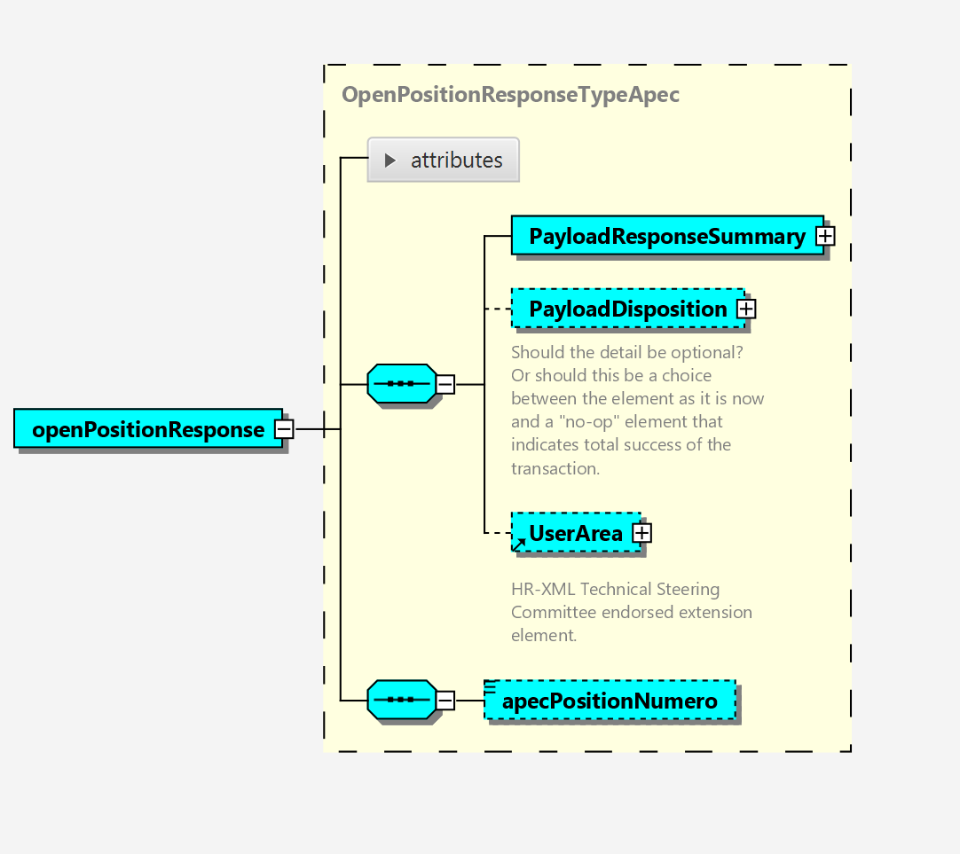

1.4 SEP and SIDES format

Examples of calls and returns are available in addition to this documentation. (ref. ADEP V5 - Documentation Technique\Exemples\Exemples flux v5)

2. Modify an offer

This service is no longer available in ADEP. However, it is always exposed by the offer module's wsdl but no operation will be performed if you use it. Once the advert has been sent to ADEP, it can be modified via the www.apec.fr website or by sending a request by email to supportadep@apec.fr.

3. List offers from a recruiter

This service allows you to retrieve a list of job offers all issued by the same recruiter. If no recruiter identifier is provided, the list of offers for the recruiter connected is returned.

3.1 Detailed description
SEP Web Service listRecruiterPositionOpenings
SIDES Web Service listRecruiterPositionOpenings

Context of use The list of offers is available to all recruiters who have subscribed to the service.

Parties involved Recruiter

Pre-conditions Be an ADEP subscriber.

Description A recruiter with rights can retrieve all of a recruiter's offers.

Exceptions The recruiter has not been found in the Apec database.

Post-conditions

3.2 Input data

3.2.1 SEP format
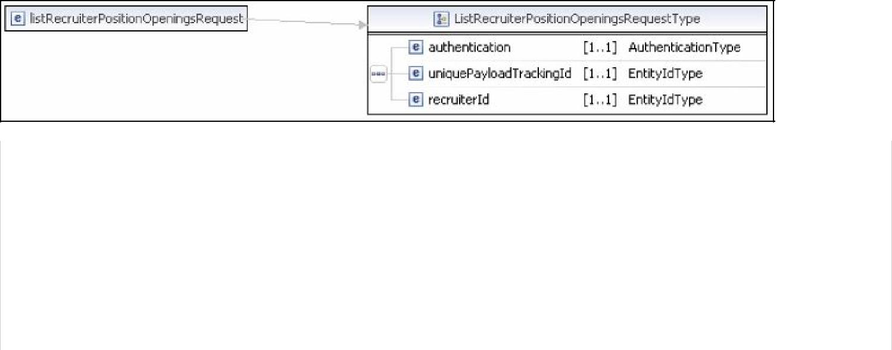

Parameter name | Type of | Owner | Description | Processing | Remarks
 | parameter | type |  | ADEP
authentication |  | ADEP | authentication data | required
 |  |  | from the ADEP client
uniquePayload-TrackingId |  | HR-XML | transaction identifier | required
 |  | CPO
recruiterId |  | HR-XML | Apec identifier of the ADEP subscriber for | required | 9-character
 |  | CPO | which you wish to obtain the list of offers |  | integer.
 |  |  | created

3.2.2 SIDES format

Parameter name | Type of | Owner | Description | Processing | Remarks
 | parameter | type |  | ADEP
authentication |  | ADEP | authentication data | required
 |  |  | from the ADEP client
uniquePayload-TrackingId |  | HR-XML | transaction identifier | required
 |  | CPO
recruiterId |  | HR-XML | Apec identifier of the ADEP subscriber for | required | 9-character
 |  | CPO | which you wish to obtain the list of offers |  | integer.
 |  |  | created

3.3 Output data

The service returns a list of offers.

3.3.1 SEP format

The PositionsCollection structure contains a list of Position-OpeningType structures containing offer data (see section V.1 below).

3.3.2 SIDES format
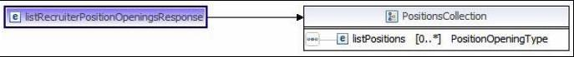

The PositionsType structure contains a list of SidesPositionOpening-Type structures containing offer data (see section VI.1 below).

4. Obtain the status of an offer

This service allows you to find out the current status of one or more offers on the APEC website.

4.1 Detailed description

SEP Web Service getPositionStatus

SIDES Web Service getPositionStatus

Context of use Retrieval of the status of an offer is available to all recruiters who have subscribed to the service.

Parties involved Recruiter

Pre-conditions The offer has already been created.

Description This service enables recruiters to find out the status of a given offer.

Exceptions The offer is not found in the Apec database.

Post-conditions

4.2 Input data
Please note: Two pieces of information can now be provided as input (client reference and Apec reference). The requirement is to provide at least one of the two. If both are provided, either they match and the service returns the only offer, or they do not match/the offer does not exist and the service returns an error.

4.2.1 SEP format
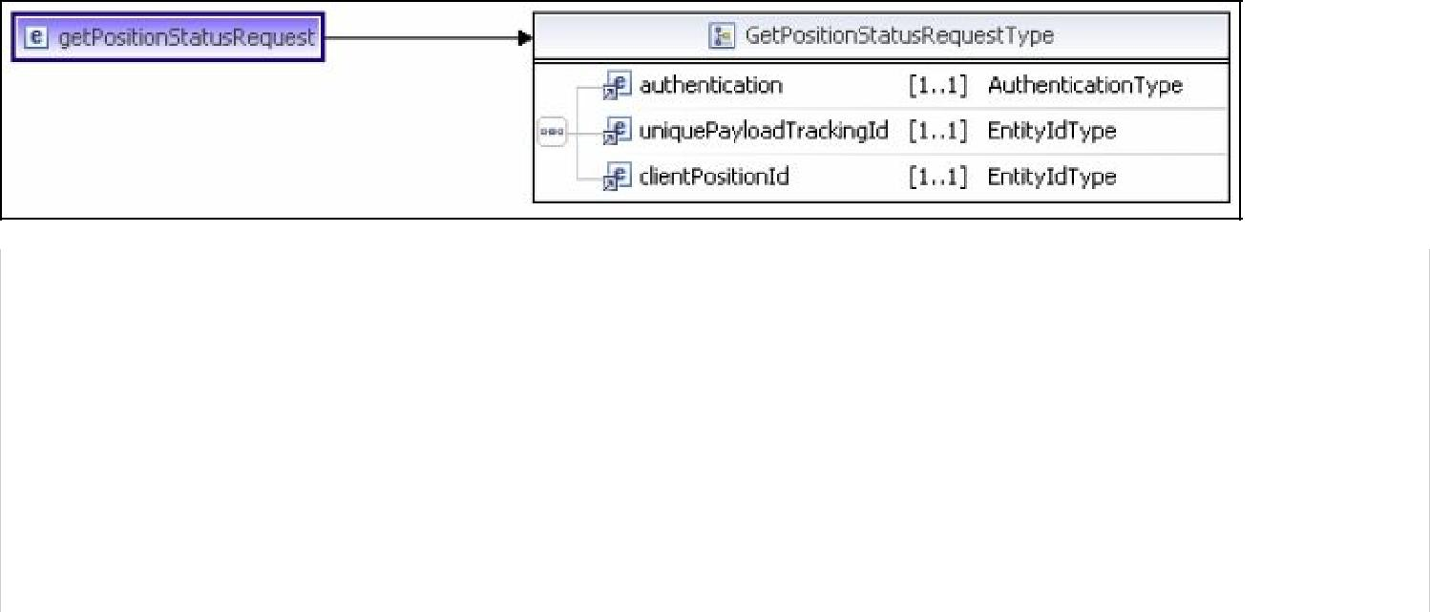

Parameter name | Type of | Owner | Description | Processing | Remarks
 | parameter | type |  | ADEP
 |  | ADEP | authentication data | required
authentication | Authentication-Type |  | from the ADEP client
 |  | HR-XML | transaction identifier | required
uniquePayload-TrackingId | EntityIdType | CPO
 |  | HR-XML | Offer identifier in the | required | 20 characters maximum.
clientPositionId | EntityIdType | CPO | client’s HRIS |  | We recommend
 |  |  |  |  | the concatenation of
 |  |  |  |  | partnerId+'-'+ your ref.
 |  | HR-XML | Offer identifier in the Apec IS | optional
 |  | CPO

4.2.2 SIDES format

Parameter name | Type of | Owner | Description | Processing | Remarks
 | parameter | type |  | ADEP
authentication | Authentication-Type | ADEP | authentication data | required
 |  |  | from the ADEP client
uniquePayload-TrackingId | EntityIdType | HR-XML | transaction identifier | required
 |  | CPO
clientPositionId | EntityIdType | HR-XML | Offer identifier in the | required | 20 characters maximum.
 |  | CPO | client’s HRIS |  | We recommend
 |  |  |  |  | the concatenation of
 |  |  |  |  | partnerId+'-'+ your ref.
apecPositionNumero | EntityIdType | HR-XML | Offer identifier in the Apec IS | optional
 |  | CPO

4.3 Output data

4.3.1 SEP and SIDES format

This service returns an XSD string containing the status of the offer. Any values returned by this service can be obtained by using the service for obtaining domain values for the STATUT_OFFRE_DOMAIN domain.

5. Change the status of an offer

Changing the status of an offer enables two actions to be taken: unpublishing or republishing an offer.

5.1 Detailed description

SEP Web Service updatePositionStatus

SIDES Web Service updatePositionStatus

Context of use Changing the status of an offer is available to all recruiters who have subscribed to the service.

Parties involved Recruiter

Pre-conditions The offer already exists in the APEC database.

Description The recruiter with rights can change the status of an offer to unpublish it, for example.

Exceptions The offer has not been found. The new status is not known. The change of status is not authorised.

Post-conditions The status of the offer has changed.

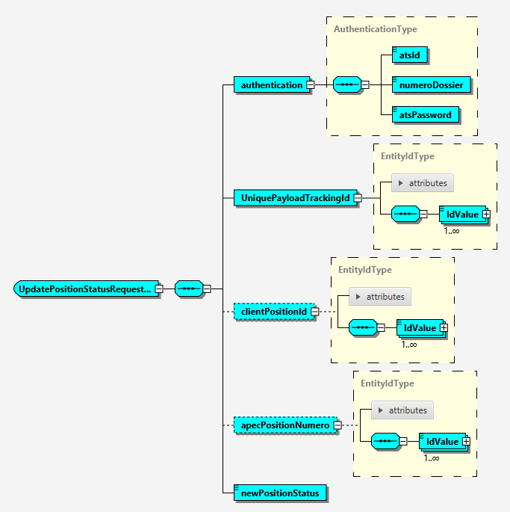

5.2 Input data

5.2.1 SEP format

Parameter name | Type of | Owner | Description | Processing | Remarks
 | parameter | type |  | ADEP
authentication |  | ADEP | authentication data | required
 | Authentication-Type |  | from the ADEP client
uniquePayload-TrackingId |  | HR-XML | transaction identifier | required
 | EntityIdType | CPO
clientPositionId | EntityIdType | HR-XML | offer identifier in | optional | 20 characters maximum
 |  | CPO | the client's HRIS
apecPositionNumero | EntityIdType | HR-XML CPO | Offer identifier in the Apec IS | optional
newPosition-Status |  | XSD | new status of the offer | required | domain
 | string |  |  |  | STATUT_OFFRE_DOMAIN

At least 1 of the following fields must be provided: clientPositionId, apecPositionNumero

5.2.2 SIDES format

Parameter name | Type of | Owner | Description | Processing | Remarks
 | parameter | type |  | ADEP
authentication | Authentication-Type | ADEP | authentication data | required
 |  |  | from the ADEP client

 |  | HR-XML | transaction identifier | required
uniquePayload-TrackingId | EntityIdType | CPO
 |  | HR-XML | offer identifier in | optional | 20 characters maximum
clientPositionId | EntityIdType | CPO | the client's HRIS
apecPositionNumero | EntityIdType | HR-XML CPO | Offer identifier in the Apec IS | optional
 |  | XSD | new status of the offer | required | domain
newPosition-Status | string |  |  |  | STATUT_OFFRE_DOMAIN

At least 1 of the following fields must be provided: clientPositionId, apecPositionNumero

5.3 Output data

See 1.3 above.

6. Get an offer

This service allows you to find out an offer on the APEC website

6.1 Detailed description

SEP Web Service getPosition

SIDES Web Service getPosition

Context of use Retrieval of an offer is available to all recruiters who have subscribed to the service.

Parties involved Recruiter

Pre-conditions The offer has already been created.

Description This service enables recruiters to find out a given offer.

Exceptions The offer is not found in the Apec database.

Post-conditions

6.2 Input data
Note: Only one information can be provided as input (Apec reference). This information is mandatory. If the offer does not exist and the service returns an error.

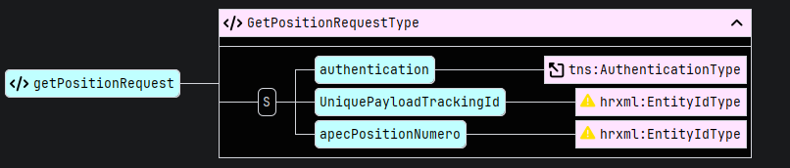
6.2.1 SEP format

Nom du paramètre | Type du | Propriétaire | Descriptif | Traitement | Remarques
 | paramètre | du type |  | ADEP
authentication | Authentication-Type | ADEP | authentication data | required
 |  |  | from the ADEP client
uniquePayloadTrackingId | EntityIdType | HR-XML | transaction identifier | required
 |  | CPO
apecPositionNumero | EntityIdType | HR-XML | Offer identifier in the Apec IS | required
 |  | CPO

6.2.2 SIDES format

Nom du paramètre | Type du | Propriétaire | Descriptif | Traitement | Remarques
 | paramètre | du type |  | ADEP
authentication | Authentication-Type | ADEP | authentication data | required
 |  |  | from the ADEP client
uniquePayloadTrackingId | EntityIdType | HR-XML | transaction identifier | required
 |  | CPO
apecPositionNumero | EntityIdType | HR-XML | Offer identifier in the Apec IS | required
 |  | CPO

6.3 Output data

6.3.1 SEP format

This service returns an XSD type GetPositionResponseType.

Nom du paramètre | Type du | Propriétaire | Descriptif | Traitement | Remarques
 | paramètre | du type |  | ADEP
clientPositionId | EntityIdType | ADEP | Offer identifier in the | required
 |  |  | client’s HRIS
position | PositionOpeningType | HR-XML | Offer | required
uniquePayloadTrackingId | EntityIdType | HR-XML | transaction identifier | required
 |  | CPO
apecPositionNumero | EntityIdType | HR-XML CPO | Offer identifier in the Apec IS | required

6.3.2 SIDES format

This service returns an XSD type GetPositionResponseType.

Nom du paramètre | Type du | Propriétaire | Descriptif | Traitement | Remarques
 | paramètre | du type |  | ADEP
clientPositionId | EntityIdType | ADEP |  | required
 |  |  | Offer identifier in the
 |  |  | client’s HRIS
position | PositionOpeningType | HR-XML | Offer | required
uniquePayload-TrackingId | EntityIdType | HR-XML | transaction identifier | required
 |  | CPO
apecPositionNumero | EntityIdType | HR-XML CPO | Offer identifier in the Apec IS | required

X. Elements and types of SEP module

1. The PositionOpeningType type
This type is derived from the HR-XML SEP standard. It is used in the SEP module to convey data relating mainly to the offer, but also to the actual client (if operating in indirect client mode). The following services are available:

Create an offer - input data (IX.1.2.1 above)
List offers from a recruiter - output data (IX3.3.1 above)
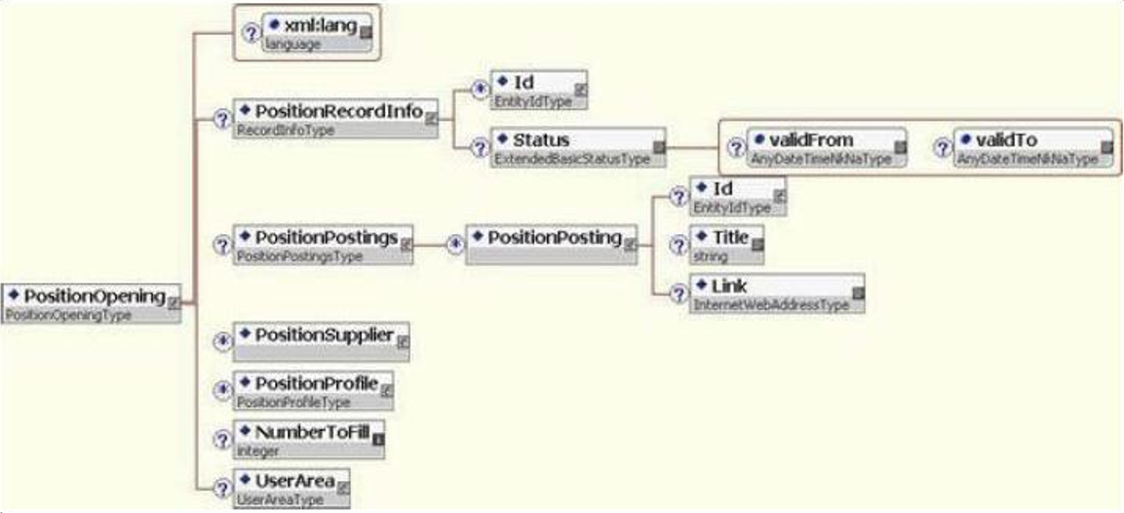

Element | Description | ADEP processing | Format
xml:lang |  | Ignored
PositionRecordInfo |  | Ignored
PositionPostings | Other publications | Ignored
PositionSupplier | Apec contact for the offer in question | Mandatory, only one authorised
PositionProfile | Offer profile | Mandatory, only one authorised
NumberToFill | Number of positions vacant | Mandatory | Integer between 1 and 10
UserArea |  | Ignored

1.1 PositionSupplier element

This element is required solely in order to specify the role of the Apec contact and to indicate to ADEP whether it is a partner recruiting its own needs (indirect client mode).

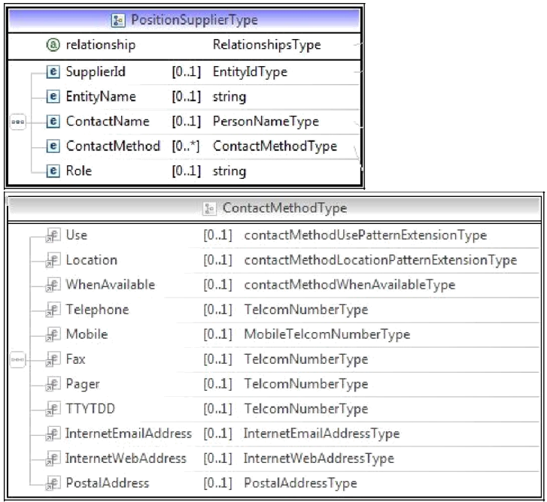

Element | Description | ADEP processing | Format
 | Role of the recruiting company | Mandatory for a job offer and optional for an internship offer as it’s initialized by default to self | This indicates the role of the recruiting company,
 |  |  | which has an impact on the way in which information
 |  |  | provided in the Organization element will be analysed.
relationship |  |  | See 1.3 below
 |  |  | Possible values for a job offer:
 |  |  | "self” if direct client
"broker” if indirect client
For an internship offer the client is initialized by default as direct
SupplierId |  | Ignored
EntityName |  | Ignored
ContactName |  | Ignored
ContactMethod |  | Ignored
Use |  | Ignored
Location |  | Ignored
WhenAvailable |  | Ignored
Telephone |  | Ignored
Mobile |  | Ignored
Fax |  | Ignored
Pager |  | Ignored
TTYDD |  | Ignored
 |  | Ignored
InternetEmail-
Address
InternetWeb-Address |  | Ignored
PostalAddress |  | Ignored
Role |  | Ignored

1.2 PositionProfile element
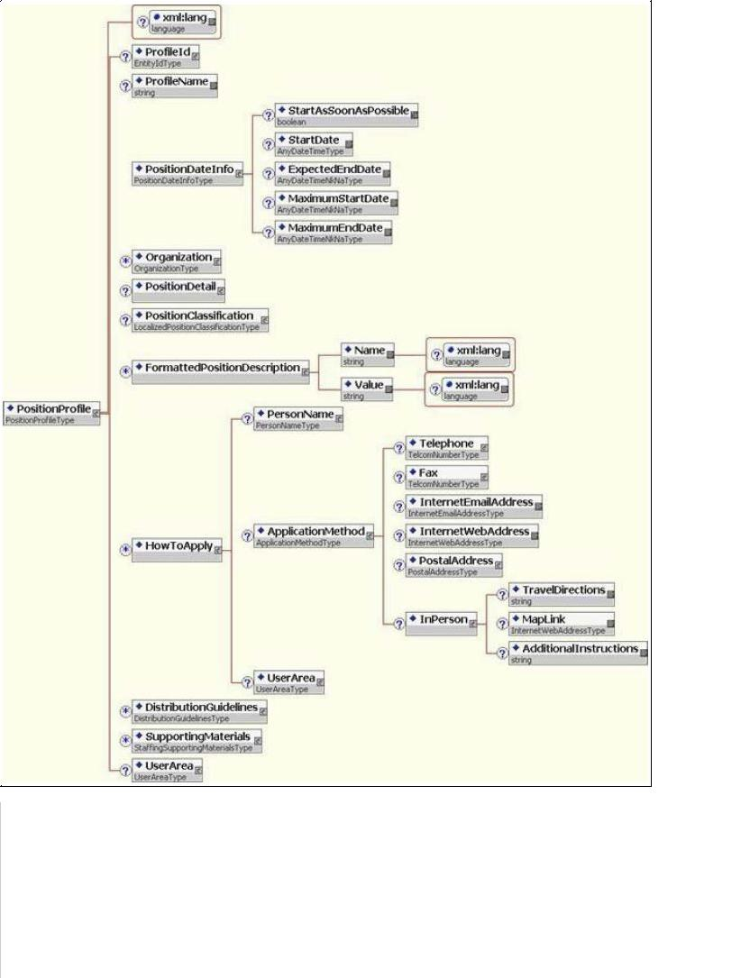

Element | Description | ADEP processing | Format
xml:lang (PositionProfile) | Language of the offer | Mandatory | ISO code 639-1 with 2
 |  |  | characters
ProfileId | Identifier of | Mandatory | 20 characters max. When
 | the offer, that is to |  | an offer is created, the client must provide
 | Say the client |  | its
 | reference |  | own identifier which must be unique.
ProfileName | Identification | Mandatory | "APEC”
 | of the Apec profile
PositionDateInfo | Time | Required by MS
 | limits | but not known by
 | of existence of the | ADEP
 | position
Organization | information | Required, only one | see 1.3 below
 | relating to | authorised
 | the recruiting
 | company
PositionDetail | Offer details | Mandatory | see 1.4 below
PositionClassification |  | Ignored
FormattedPositionDescription | Information | 3 elements required | see 1.5 below
 | codified on
 | the offer
HowToApply | Recipient | Optional, only the | Via this element it is possible
 | of the | first element is | to provide the precise details
 | applications |  | for the contact with
 |  | taken into account. | whom candidates can
 |  | Required if | apply directly. For an
 |  | you are | offer in indirect client
 |  | a subscriber | mode, it should be a
 |  | to PUSH ADEP. | contact for the actual client.
HowToApply.PersonName | Person in charge of applications | Optional
howToApply.PersonName.Affix type='formOfAdress' | Civil status of the person responsible for monitoring applications | Mandatory if HowToApply.PersonName is provided | See CIVILITE_DOMAIN
howToApply.PersonName.FamilyName | Name of the person in charge of applications | Mandatory if HowToApply.PersonName is provided | 30 characters maximum
howToApply.PersonName.GivenName | First name of the person in charge of applications | Mandatory if HowToApply.PersonName is provided | 30 characters maximum
howToApply.PersonName.Affix type='qualification' | Position of the person in charge of applications | Mandatory if HowToApply.PersonName is provided | 128 characters maximum
HowToApply.ApplicationMethod | Recipient | Required if element
 | of the | "HowToApply
 | applications | supplied
HowToApply.ApplicationMethod. |  | Ignored
Telephone
HowToApply.ApplicationMethod. |  | Ignored
Fax
 | Email to | Required if | 240 characters max.
HowToApply.ApplicationMethod. | apply | you are
InternetEmailAddress |  | a subscriber
 |  | to PUSH ADEP.
 | URL to | Optional | 2000 characters max.
HowToApply.ApplicationMethod. | apply
InternetWebAddress
 |  | Ignored
HowToApply.ApplicationMethod.
PostalAddress
 |  | Ignored
HowToApply.ApplicationMethod.
InPerson
 |  | Ignored
HowToApply.UserArea
 |  | Ignored
DistributionGuidelines
 |  | Ignored
SupportingMaterials
 |  | Ignored
UserArea

1.3 Organization element

This element stores data relating to the recruiting company. By recruiting company, we mean:

- either the ADEP partner company itself, if it is recruiting for its own needs (direct client mode)

- or the actual client, if the ADEP partner company is acting as an intermediary (indirect client mode)

The appropriate mode (direct client/indirect client) must be indicated via the value of the relationship attribute of thePositionSupplier element (see 1.1 above).

Indirect client mode is only valid in the following cases:

- Companies with an agreement of the type [Firms (Syntec or not), temporary employment companies, or PRISME] which do not recruit for temporary work or which do not recruit on their own behalf.

Depending on the value specified in the relationship attribute, ADEP will treat the Organization element in two distinct ways:

1.3.1 Direct client mode

In this case, only the ContactInfo[0]/ContactMethod/InternetEmailAddress element is required:
Element | Description | ADEP processing | Format
ContactInfo.ContactMethod.InternetEmailAddress | Email contact for the offer |  | 120 characters max.
 |  | Optional | If the field is not
 |  |  | provided, it will be
 |  |  | with the default email
 |  |  | that of the ADEP contact person.

1.3.2 Indirect client mode

In this case, this element contains the data relating to the actual client, and must be supplied in full, as specified in chap. XII.4 below.

PLEASE NOTE: in indirect client mode, it is not possible to specify two separate emails, one for the intermediary (the contact's email) and one for the actual client.

1.4 PositionDetail element

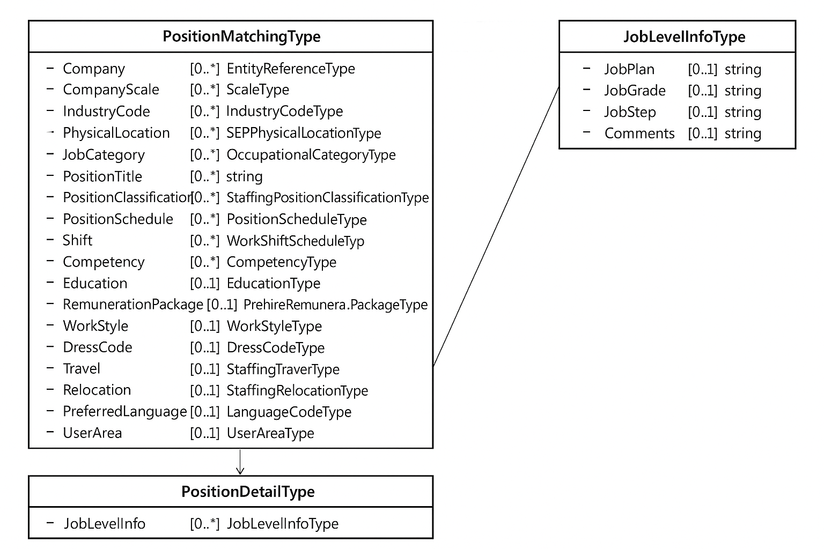

Element | Description | ADEP processing | Format
Company |  | Ignored
CompanyScale |  | Ignored
IndustryCode | Company NAF code | Mandatory, only one | See 1.6 below
 | contact person, | authorised
 | will appear on the offer
PhysicalLocation | Job location | Mandatory | See 1.7 below
JobCategory |  | Ignored
PositionTitle | Job title | Mandatory, only one | 80 characters max. The job title must contain
 |  | authorised | the indication "M/F". Otherwise, it is
 |  |  | added by the application if the number of characters is
 |  |  | less than or equal to 76.
PositionClassification |  | Ignored
PositionSchedule |  | Ignored
Shift |  | Ignored
Competency |  | Mandatory | See XII.3 below
Education | Level of study for an internship offer | Mandatory for an internship offer
RemunerationPackage |  | Mandatory for a job offer and becomes mandatory for an internship offer if displayedPay = 4 (idNomSalaire = X € net per month). | See 1.8 below
WorkStyle |  | Ignored
DressCode |  | Ignored
Travel |  | Ignored
Relocation |  | Ignored
PreferredLanguage |  | Ignored
UserArea |  | Mandatory
UserArea.Duration | Contract duration | Mandatory, if the | The duration must be expressed in months, with a minimum value
 |  | type of contract | of 0(0 corresponds to a value of <1 month)
 |  | is a fixed-term contract or | An offer with a permanent contract cannot have a contract
 |  | temporary contract or intership | duration
UserArea.StatusJob | Position status | Mandatory for a job offer and optional for an internship offer, as it is initialized by default. | Indicates the status of the position.
 |  |  | Values to choose from for a job offer:
 |  |  | "CADRE_PRIVE"
 |  |  | "CADRE_PUBLIC"
"AGENT_DE_MAITRISE"
For an internship offer: the value is “STAGE”
userArea.displayedPay | Salary indicated | Mandatory | See domain with value – SALAIRE_TEXTE_DOMAIN
userArea.partTime | Part-time work | Mandatory | Boolean
userArea.partTimeDuration | Part-time working arrangements | Mandatory if part-time | See domain with value – TEMPS_PARTIEL_DUREE_DOMAIN
userArea.urlVideo | Video url | Optional | Video Url: youtube or youtu.be
userArea.datePositionTaken | Date position taken up | Optional | Date > than current date
userArea.releaseDate | Publication date | Optional | Date > than today's date and <= than today's date + 60 days.  Date < than date position taken up
userArea.jobType | Type of contract | Mandatory | See TYPE_CONTRAT_DOMAIN
userArea.NumeroDossier | Identifier of the contact person (or recruiter) | Used for getPosition | Indicates the identifier of the recruiter who owns the offer
userArea.IsEditable | indicates whether the offer is updatable | Used for getPosition | This flag is set to true when:  The offer originates from ADEP and the status is one of the following:  - HORS_LIGNE_MODIFICATION_RECRUTEUR  - HORS_LIGNE  - EN_LIGNE  - BROUILLON
userArea.RemoteWork | Type of remote work | Optional | Indicates the type of remote work  Values to choose:  "PONCTUEL_AUTORISE"  "PARTIEL_POSSIBLE"  "TOTAL_POSSIBLE”
JobLevelInfo |  | Ignored


1.5 FormattedPositionDescription element

This element is used to enter information about the offer in a format agreed between Apec and the partner.
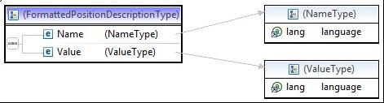

Three mandatory occurrences of the element. Depending on the nature of the information, the Name and Value _elements must be filled in as follows (the _xml: lang attributes are not known):
Information | Description | ADEP processing | Element value Name | Element value Value
Type of offer | indicates whether the offer is | Mandatory for a job offer and for an internship offer the value is initialized to ODD | POSITION_TYPE | ODD
 | ODD |  |  | ODD
 | or ODC (confidential |  |  | ODC
 | offer)
Job description | Description of the offer | Mandatory | POSITION_DESCRIPTION | 200 characters min and
 |  |  |  | 3,000 characters max.
 |  |  |  | Text block authorising
 |  |  |  | simple formatting
 |  |  |  | HTML tags:
 |  |  |  | Bold, italics,
 |  |  |  | underline, carriage return,
 |  |  |  | bullet points.
Description of the organization | Description of the organization | Mandatory | ORGANIZATION_DESCRIPTION | Minimum 100  Maximum 3,000 characters  Text block authorising  simple formatting  HTML tags:  Bold, italics,  underline, carriage return,  bullet points.
Profile description | Profile description | Mandatory | PROFILE_DESCRIPTION | Minimum 100  Maximum 3,000 characters  Text block authorising  simple formatting  HTML tags:  Bold, italics,  underline, carriage return,  bullet points.
Advice to candidates | Advice to candidates | Optional | PRESENTATION_DESCRIPTION | Maximum 500 characters  Text block authorising  simple formatting  HTML tags:  Bold, italics,  underline, carriage return,  bullet points.
Recruitment process | Recruitment process | Optional | RECRUITMENT_DESCRIPTION | Maximum 500 characters  Text block authorising  simple formatting  HTML tags:  Bold, italics,  underline, carriage return,  bullet points.
Sign displayed with the offer | Sign displayed with the offer | Mandatory | ORGANIZATION_NAME | Maximum 255 characters
Display of the company’s | Indicator for | Compulsory, only taken into | POSITION_DISPLAY_LOGO | A choice of two values:
logo | display of the company’s | account |  | "true”
 | logo (taken | if the offer is not |  | "true”
 | into account for a | Confidential. Takes the logo of the last offer |  | "false"
 | non-confidential
 | offer)

1.6 IndustryCodeType element

This element is required and refers to the NAF code of the contact company, which may also be the issuer of the offer. Only one element is taken into account by ADEP, identified by the value of the classificationName attribute.

The value of this element must be taken from the INSEE standard "NAF ver. 2, 2008".
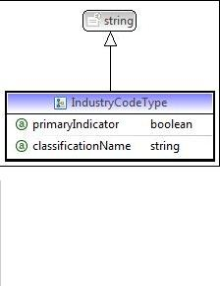

Element | Description | ADEP processing | Format
IndustryCode | NAF code | Mandatory | 5 characters max
primaryIndicator |  | Ignored
classificationName | Name of the organization | Mandatory if IndustryCode is supplied | "INSEE
 | defining this agreement

1.7 PhysicalLocation element

This SEPPhysicalLocation element is used to indicate the location of the position.

Two occurrences of this element are required, one with the Name sub-element set to LOCATION_CODE_COMMUNE (official geographic INSEE code, excluding cedex), the other with this same sub-element set to LOCATION_ZONE_DEPLACEMENT (travel zone).

Only one city is allowed.

Links:

- The INSEE municipalities can be accessed here: http://www.insee.fr/fr/methodes/nomenclatures/cog/default.asp
- INSEE countries can be accessed here: http://www.insee.fr/fr/methodes/nomenclatures/cog/pays.asp
Note: the ISO 3166 standard available on wikipedia corresponds to the 2007 version, which is no longer maintained.

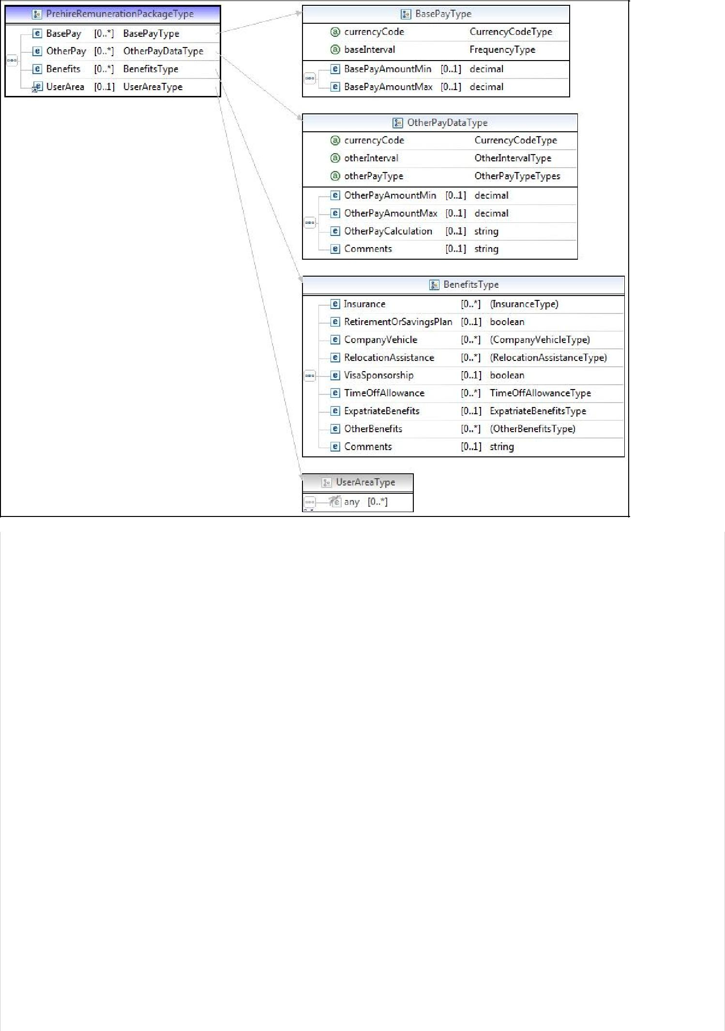

Element | Description | ADEP processing | Format
 | Owner | Optional
Id | of the reference source
 | Type of location | Mandatory | Two possible values to distinguish
Name |  |  | the location of the job:
 |  |  | “LOCATION_CODE": municipality code or country code (see Area.Value)
 |  |  | "LOCATION_ZONE_DEPLACEMENT": text from a list (see
 |  |  | Area.Value)

SpatialLocation |  | Ignored
TravelDirections |  | Ignored
Area | Location | Mandatory, only one
 |  | element in
 |  | free text and only
 |  | one element in
 |  | INSEE municipality
 |  | code
Area.type | Indicates the | Mandatory | value = "INSEE":
 | type of value |  | France: http://www.insee.fr/fr/methodes/nomenclatures/cog/default.asp .
 |  |  | Country: http://www.insee.fr/fr/methodes/nomenclatures/cog/pays.asp .
 |  |  | type="APEC"
 |  |  | See Value field description
Area.Value | INSEE or | Mandatory
 | Zone code |  | If Type="INSEE" & Name = "LOCATION_CODE": Official geographical code
 |  |  | INSEE (e.g. 99109 for Germany, 75101 for Paris 1st)
 |  |  | If Type ="APEC" & Name = "LOCATION_ZONE_DEPLACEMENT": One of the
 |  |  | following values:
 |  |  | AUCUN
 |  |  | DEPARTEMENT
 |  |  | REGIONAL
 |  |  | NATIONAL
 |  |  | UE
 |  |  | HORS_UE
Area.Area |  | Ignored
PostalAddress |  | Ignored
Comments |  | Ignored

1.8 RemunerationPackage element

This PrehireRemunerationPackage element used to express the desired annual salary, in euros

Element | Description | ADEP processing | Format
 | Remuneration | Mandatory, only one
BasePay | required, format | authorised
 | standard
 | Currency code | Ignored | Is considered to be "EUR”
currencyCode
 |  | Ignored | If this element was included, its value
baseInterval |  |  | should be "Annually".
 | Minimum salary | Mandatory for a job offer and for an offer only in the case of IdNomSalaire (DisplayedPay = 4) X € net per month. | 9-character integer (amount in euros). For a job offer
BasePay.BasePayAmountMin | for offers search |  | the amount will be converted into thousands of euros,
 |  |  | rounded off to the nearest thousand;
if a decimal is given, it will be converted to an integer.
However, for an internship offer, the amount is taken as it is.
 |  |  | This field is not displayed in the offer, but is used for the
 |  |  | search for offers.
 | Maximum salary | Mandatory for a job offer and optional for an internship offer, since it will be initialized by default to salaireMinimum. | 9-character integer (amount in euros).
BasePay.BasePayAmountMax | For offers search |  | For a job offer, the amount will be converted into thousands of euros,
 |  |  | rounded off to the nearest thousand;
if a decimal is given, it will be converted to an integer.
However, for an internship offer, the amount is taken as it is.
 |  |  | This field is not displayed in the offer, but is used for the
 |  |  | search for offers.
 |  | Ignored
OtherPay
 |  | Ignored | If this item were included, its value would be
OtherInterval |  |  | "Annually”
 |  | Ignored
OtherPayType
 |  | Ignored
OtherPayAmountMin
 |  | Ignored
OtherPayAmountMax
OtherPay.OtherPayCalculation |  | Ignored
Comments |  | Ignored
Benefits |  | Ignored
UserArea |  | Ignored

XI. ELEMENTS AND TYPES OF SIDES MODULE

1. The SidesPositionOpeningType type
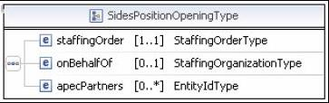

The SidespositionOpeningType type is used in the SIDES module to convey data relating mainly to the offer, but also to the actual client (if operating in indirect client mode).

It can be found in the following departments:

Create an offer - input data (IX.1.2.2 above)
- List offers from a recruiter - output data (IX.3.3.2 above)
The three elements of the SidesPositionOpeningType type are detailed below.

1.1 staffingOrder element

This element is a StaffingOrderType, a type derived from the HR-XML SIDES standard. This element stores the data relating to the offer to be created or updated.
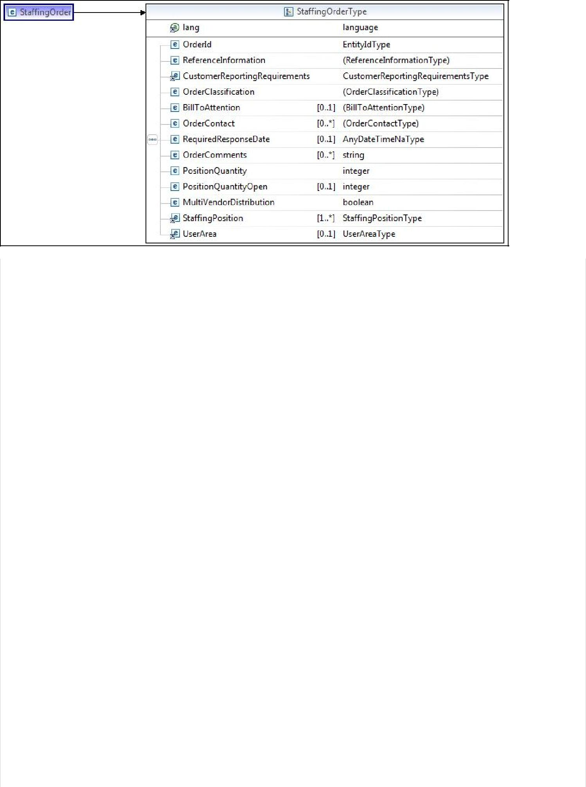

Element | Description | ADEP processing | Format
xml:lang | Language of the offer | Mandatory | 2-character ISO 639-1 code
OrderId | Client identifier | Mandatory | 20 characters max. When
 | for the offer, that |  | creating an offer, the client must
 | Is to say, the client |  | provide its own unique identifier.
 | reference
ReferenceInformation |  | Ignored, required by | This element is mandatory for SIDES but
 |  | SIDES | is not taken into account by ADEP.
CustomerReporting-Requirements |  | Ignored, required by | This element is mandatory for SIDES but
 |  | SIDES | is not taken into account by ADEP.
OrderClassification | Information on the |  | See 1.1.1 below
 | status
 | and the type of
 | the offer
BillToAttention |  | Ignored
OrderContact | Details for
 | the Apec
 | contact for the offer
 | in question.
RequiredResponsableDate |  | Ignored
OrderComments |  | Ignored
PositionQuantity |  | Ignored, required by | This element is mandatory for SIDES but
 |  | SIDES | is not taken into account by ADEP.
 |  |  | Its value should be "1".
PositionQuantityOpen |  | Ignored
MultiVendorDistribution |  | Ignored, required by | This element is mandatory for SIDES but
 |  | SIDES | is not taken into account by ADEP.
StaffingPosition |  | Mandatory, only one | See 1.1.3 below
 |  | authorised
UserArea |  | Mandatory
UserArea.DisplayLogoType | Indicator for | Mandatory, is | Must be equal to:
 | display of the | taken into account | "true”
 | logo | only if the offer is | "true”
 |  | not confidential | "false"
 |  | ss
UserArea.Duration | Contract duration | Mandatory, if the | The duration must be expressed in months whose minimum
 |  | type of contract | value
 |  | is a fixed-term contract or | is 1.
 |  | temporary contract or internship | An offer with an open-ended contract cannot have a
 |  |  | contract duration
UserArea.StatusJob |  | Mandatory for a job offer and optional for an internship offer, as it is initialized by default to the value STAGE. | Indicates the status of the position.
 |  |  | Values to choose from:
 |  |  | "CADRE_PRIVE"
 |  |  | "CADRE_PUBLIC"
 |  |  | "AGENT_DE_MAITRISE"
UserArea.displayedPay | Text displayed | Mandatory | See domain with value – SALAIRE_TEXTE_DOMAIN
UserArea.partTime | Part-time work | Mandatory | Boolean
userArea.partTimeDuration | Part-time working arrangements | Mandatory if part-time | See domain with value – TEMPS_PARTIEL_DUREE_DOMAIN
UserArea.urlVideo | Video url | Optional | Video Url: youtube or youtu.be
userArea.OrganizationDescription | Descriptive text of the company | Mandatory | Minimum 100  Maximum 3,000 characters
userArea.profileDescription | Profile description text | Mandatory | Minimum 100  Maximum 3000 characters
userArea.presentationDescription | Advice to candidates | Optional | Maximum 500 characters
userArea.recruitmentDescription | Description of the recruitment process | Optional | Maximum 500 characters
userArea.organizationName | Sign | Mandatory | Sign displayed with the offer
userArea.datePositionTaken | Date position taken up | Optional | Date > than current date
userArea.releaseDate | Publication date | Optional | Date > than today's date and <= than today's date + 60 days.  Date < than date position taken up
userArea.NumeroDossier | Identifier of the contact person (or recruiter) | Used for getPosition | Indicates the identifier of the recruiter who owns the offer
userArea.IsEditable | indicates whether the offer is modifiable | Used for getPosition | This flag is set to true when:  The offer originates from ADEP and the status is one of the following:  - HORS_LIGNE_MODIFICATION_RECRUTEUR  - HORS_LIGNE  - EN_LIGNE  - BROUILLON
userArea.jobType | Type of contract | Mandatory | Seer TYPE_CONTRAT_DOMAIN

1.1.1 OrderClassification element
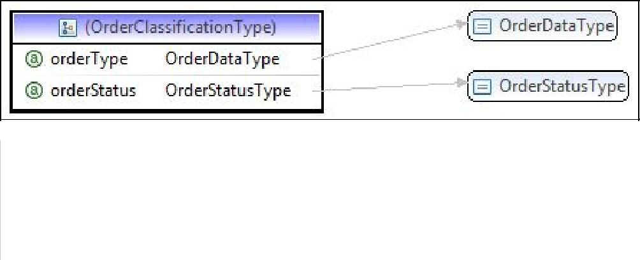

Element | Description | ADEP processing | Format
orderType | Type of offer - ODD or ODC | Mandatory | 3 characters
orderStatus | Status of the offer | Mandatory | "new" (call to the Web Service to create an offer)

1.1.2 OrderContact element

This element has become obsolete in ADEP V3 and is no longer used. In all cases, ADEP retrieves the details of the Apec contact (subscriber) and will therefore be the default partner contact who must be contacted by Apec for any request or clarification concerning the offer.

1.1.3 StaffingPositionType type
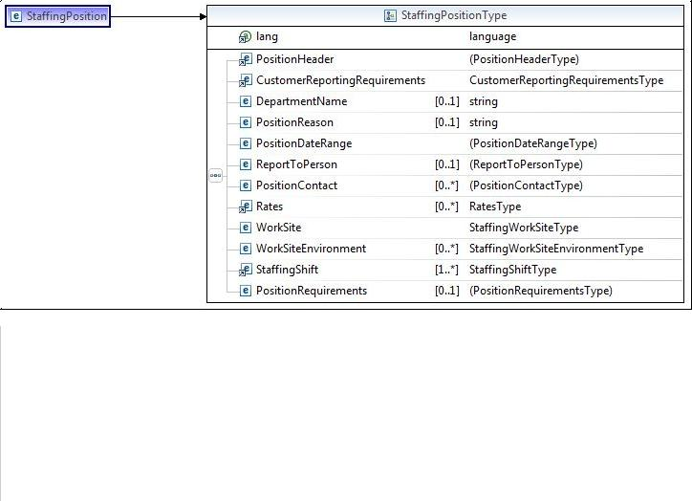

Element | Description | ADEP processing | Format
PositionHeader | Offer header | Mandatory | See 1.1.4 below
CustomerReporting-Requirement |  | Ignored, required by SIDES | This element is mandatory
 |  |  | for SIDES but is not
 |  |  | taken into account by ADEP
DepartmentName |  | Ignored
PositionReason |  | Ignored
PositionDateRange |  | Ignored, required by SIDES | This element is mandatory
 |  |  | for SIDES but is not
 |  |  | taken into account by ADEP
ReportToPerson |  | Ignored
PositionContact | Recipient of applications | Optional, only one allowed. | see 1.1.6 below
Rates | Desired remuneration | 3 elements required | see 1.1.7 below
WorkSite | Place of work | Mandatory | see 1.1.8 below
WorkSiteEnvironment |  | Ignored
StaffingShift |  | Ignored, required by SIDES | This element is mandatory
 |  |  | for SIDES but is not
 |  |  | taken into account by ADEP
PositionRequirements | Level of experience required | Mandatory | see 1.1.9 below


1.1.4 PositionHeader element
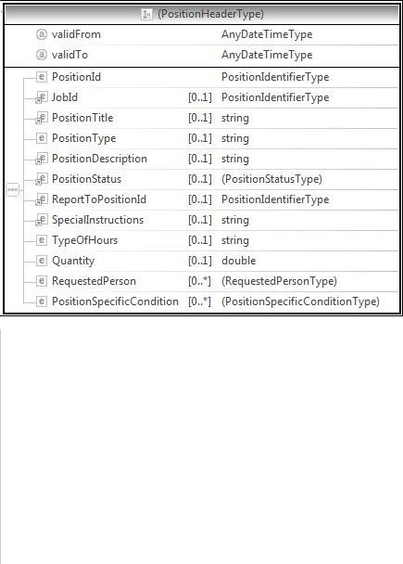

Element | Description | ADEP processing | Format
validFrom |  | Ignored
validTo |  | Ignored
PositionId | NAF code | Mandatory | see 1.1.5 below
JobId |  | Ignored
PositionTitle | Job title | Mandatory | 80 characters max. Job title
 |  |  | must be marked "M/F". Otherwise,
 |  |  | this is added by
 |  |  | the application if the number of characters
 |  |  | is less than or equal to 76.
 |  | Ignored
PositionType
 | Text of the offer | Mandatory | 200 characters min and 3,000 characters max.
PositionDescription |  |  | Text block authorising simple formatting
 |  |  | HTML tags: Bold, italics,
 |  |  | underline, carriage return, bullet points.
 | Status of the offer | Ignored
PositionStatus
 |  | Ignored
ReportToPositionId
 |  | Ignored
SpecialInstructions
 |  | Ignored
TypeOfHours
 | Number of positions to be filled | Mandatory | Integer between 1 and 10.
Quantity
 |  | Ignored
RequestedPerson
 |  | Ignored
PositionSpecificCondition


1.1.5 PositionId
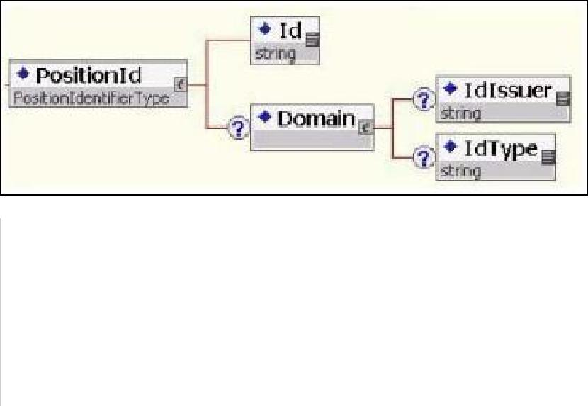

Element | Description | ADEP processing | Format
Id | NAF code | Mandatory | 5 characters max. (INSEE standard "NAF" ver. 2, 2008)
Domain | Domain identification | Mandatory
IdIssuer | Owner of the domain | Mandatory | "INSEE
IdType | Domain identifier | Mandatory | "NAF”

1.1.6 PositionContact element

This element corresponds to the contact details of the person to whom the applications are addressed: it is possible to indicate the precise details of the contact person to whom applicants can apply directly.

Comments:

Only non-confidential offers can contain this information;
URLs can only be provided if the level of service is sufficient, otherwise the offer will be rejected in its entirety.
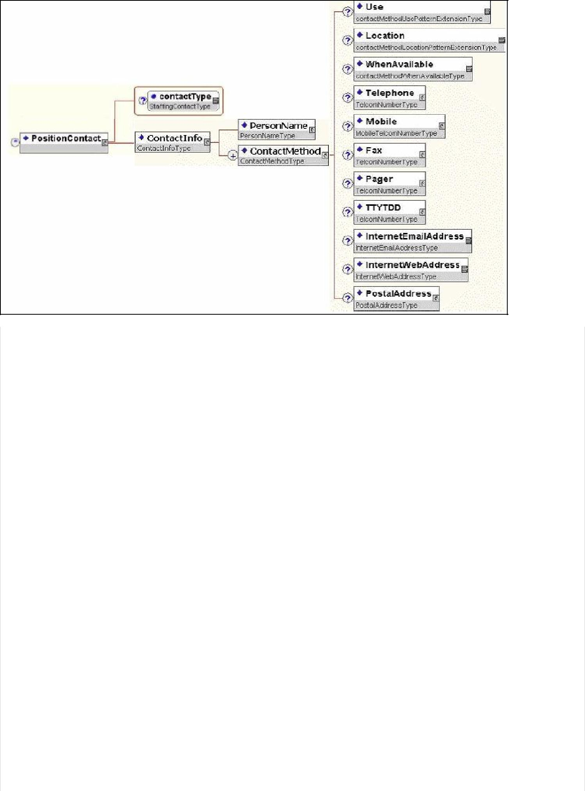

Element | Description | ADEP processing | Format
contactType | Type of contact | Mandatory | "recipient"
ContactInfo | Information on the | Mandatory
 | contact
PersonName | Contact name | Optional
PersonName.affix type= « formOfAdress » | Civil status | Mandatory if a personName element is present | See CIVILITE_DOMAIN
PersonName.givenName | First name | Mandatory if a personName element is present | 30 characters maximum
PersonName.familyName | Name | Mandatory if a personName element is present | 30 characters maximum
PersonName.affix type= « qualification » | Position | Mandatory if a personName element is present | 128 characters maximum
ContactMethod | Methods of | Mandatory, only one
 | contact | authorised
Use |  | Ignored
Location |  | Ignored
WhenAvailable |  | Ignored
Telephone |  | Ignored
Mobile |  | Ignored
Fax |  | Ignored
Pager |  | Ignored
TTYDD |  | Ignored
InternetEmail-Address |  | Mandatory, if | 240 characters max.
 |  | InternetWeb-Address
 |  | is not filled in
InternetWeb-Address |  | Mandatory, if | This is a web link to apply for a job
 |  | InternetEmail-Address | directly on the recruiter's website.
 |  | is not filled in
 |  |  | This field cannot be filled in if the offer is confidential
PostalAddress |  | Ignored

1.1.7 RatesType type
This type is used to express the desired annual salary in euros.
Three occurrences of this element are required, each with a different value for the rateType attribute:
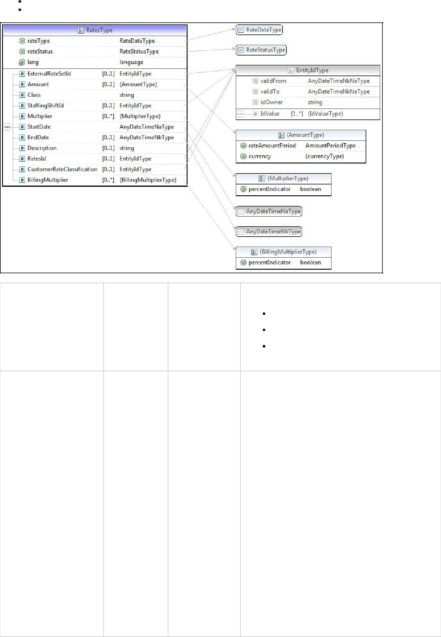
- "minPayRate": minimum salary for job searches
- "maxPayRate": maximum salary for job searches

Element | Description | ADEP processing | Format
rateType | Salary type | Mandatory
"minPayRate": minimum salary for job searches

"maxPayRate": maximum salary for job searches

"pay": free-format salary to be displayed in the offer

rateStatus |  | Ignored, required by | This element is mandatory for SIDES but is not
 |  | SIDES | taken into account by ADEP.
 |  |  | However, it is recommended to use the value
 |  |  | "proposed".
xml:lang |  | Ignored
ExternalRateSetId |  | Ignored
Amount | Minimum salary | Mandatory if | 9-character integer (amount in euros). The amount will be
 | or | "rateType | converted into thousands of euros, rounded off
 | maximum for | is "minPayRate | to the nearest thousand; if a decimal is supplied it
 | offers search | (minimum salary) | will be converted to an integer.
 |  | or "maxPayRate” | The maximum salary must be higher than the minimum salary.
 |  | (maximum salary), | This field is not displayed in the offer, but is used for the
 |  | not known otherwise | search for offers.
rateAmountPeriod | Period of | Mandatory if | "yearly"
 | reference | "rateType
 |  | is "minPayRate
 |  | (minimum salary)
 |  | or "maxPayRate”
 |  | (maximum salary),
 |  | not known otherwise
currency | Currency | Mandatory if | "EUR”
 |  | "rateType
 |  | is "minPayRate
 |  | (minimum salary)
 |  | or "maxPayRate”
 |  | (maximum salary),
 |  | not known otherwise
Class |  | Ignored, required by | This element is mandatory for SIDES but is not
 |  | SIDES | taken into account by ADEP.
 |  |  | However, it is recommended to use the value
 |  |  | "regular".
StaffingShiftId |  | Ignored
Multiplier |  | Ignored
StartDate |  | Ignored, required by | This element is mandatory for SIDES but is not
 |  | SIDES | taken into account by ADEP.
 |  |  | However, we recommend using the current date.
EndDate |  | Ignored
Description |  | Ignored
RateId |  | Ignored
CustomerRate-Classification |  | Ignored
BillingMultiplier |  | Ignored



1.1.8 StaffingWorkSiteType type

This element is used to indicate the location of the position.
Two occurrences of the WorkSite element are required. One for the INSEE municipality or country code, the other for the
travel zone.

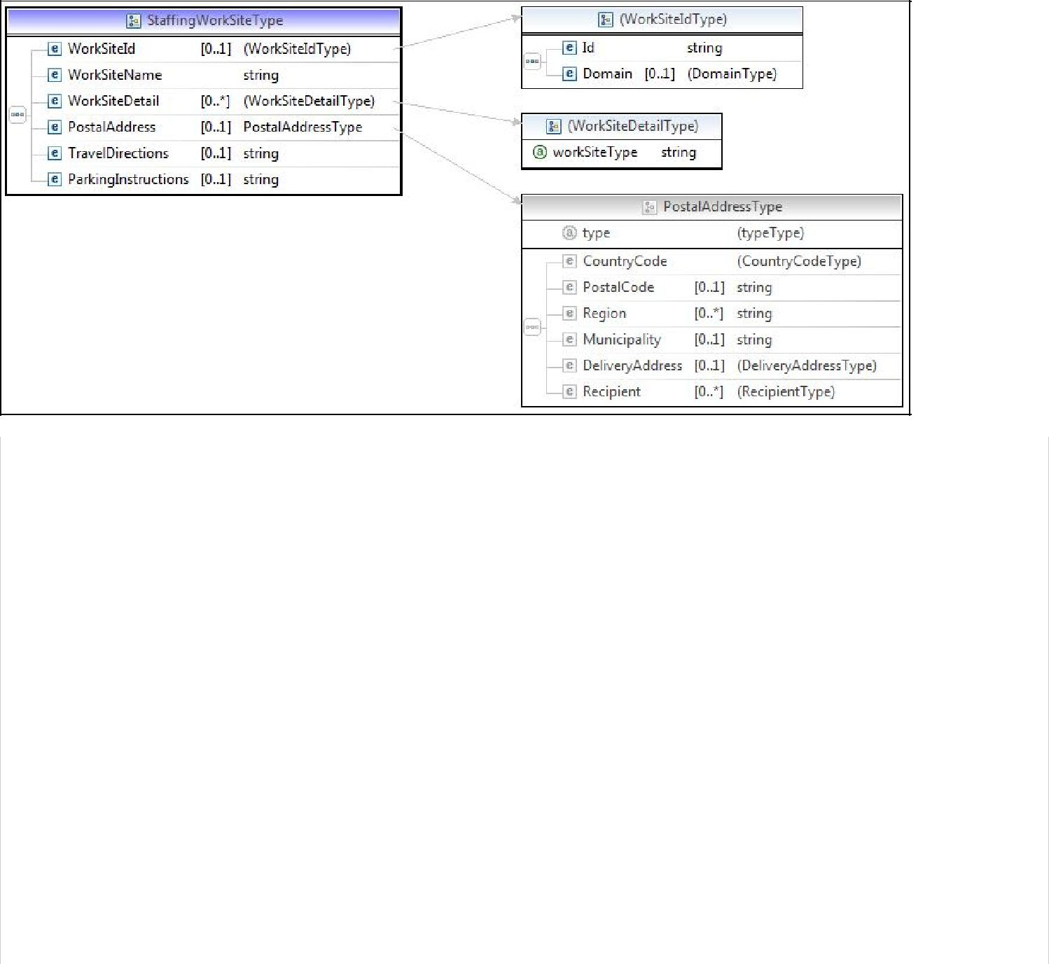

Element | Description | Processing | Format
 |  | ADEP
WorkSiteId | Location in | Mandatory
 | coded form
Id | Location code | Mandatory
Occurrence value.
-If Domain>IdIssuer="INSEE" & Domain>IdType= "LOCATION_CODE" : Official
geographical INSEE code official (e.g. 99109 for Germany, 75101 for Paris)
1st)
-If Domain>IdIssuer="APEC" & Domain>IdType=
"LOCATION_ZONE_DEPLACEMENT": One of the following values:
NO
DEPARTMENT
REGIONAL
NATIONAL
EU
OUTSIDE_EU

Domain | Information on the | Mandatory
 | domain
IdIssuer | Owner of the location code | Mandatory
-IdIssuer= "INSEE":
of the location code
(for the municipality or country code)
France: https://www.insee.fr/fr/methodes/nomenclatures/cog/default.asp .
Country: https://www.insee.fr/fr/methodes/nomenclatures/cog/pays.asp .
We use the INSEE 2015 benchmark.
-IdIssuer="APEC"
(for the travel zone)
See Id field description
IdType | Type of location code | Mandatory | Two possible values to distinguish  location code  the location of the job:  "LOCATION_CODE": for the municipality or country code (see Id field)  "LOCATION_ZONE_DEPLACEMENT": case of text from a list (see  Id field)
WorkSiteName |  | Ignored
WorkSiteDetail |  | Ignored
PostalAddress |  | Ignored
TravelDirections |  | Ignored
Parking-Instructions |  | Ignored

1.1.9 PositionRequirements element
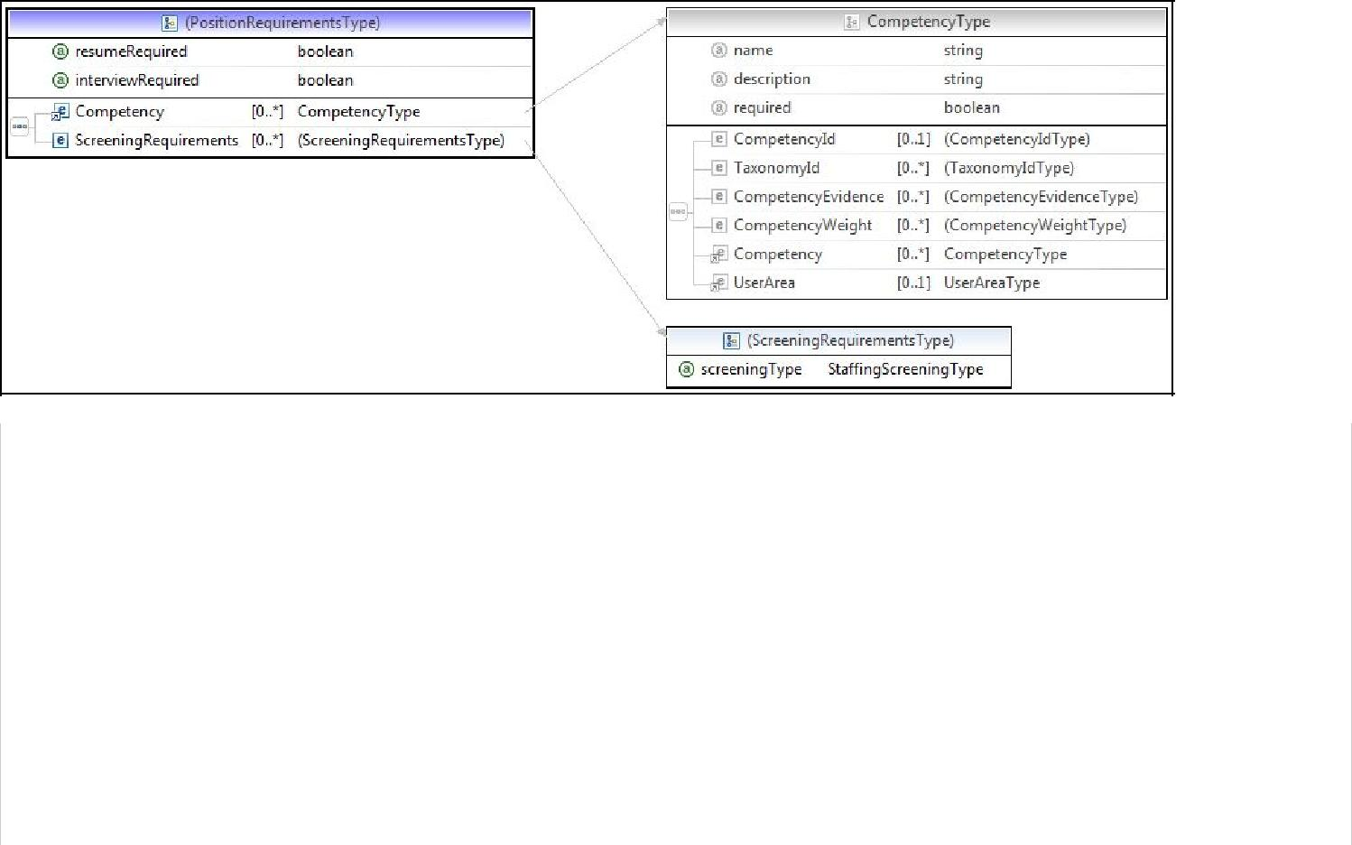

Element | Description | ADEP processing | Format
resumeRequired |  | Ignored, required for | This element is mandatory for SIDES but
 |  | SIDES | is not taken into account by ADEP.
 |  |  | However, it is advisable to enter the value
 |  |  | "false".
interviewRequired |  | Ignored, required for | This element is mandatory for SIDES but
 |  | SIDES | is not taken into account by ADEP.
 |  |  | However, it is advisable to enter the value
 |  |  | "false".
Competency | Level of experience | Mandatory, only one | See XII.3 below
 | required | authorised
ScreeningRequirements |  | Ignored

1.2 onBehalfOf element

This element is the StaffingOrganizationType, a type derived from the HR-XML SIDES standard.

This element is optional; it stores data relating to the actual client.

Indirect client mode is only valid in the following cases:

- Companies with an agreement of the type [Firms (Syntec or not), temporary employment companies, or PRISME] which do not recruit for temporary work or which do not recruit on their own behalf.

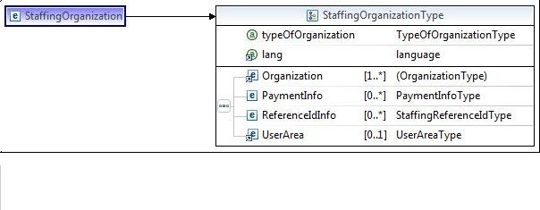

Element | Description | ADEP processing | Format
typeofOrganization | Type of company | Mandatory | "Client”
xml:lang |  | Ignored
Organization | Company data | Mandatory, only one authorised | See XII.4 below
PaymentInfo |  | Ignored
ReferenceIdInfo |  | Ignored
UserArea |  | Ignored


XII. HR-XML CPO ELEMENTS AND TYPES (COMMON TO SEP AND SIDES)

The types described in this chapter are shared by both the SEP and SIDES modules.

Their use is identical in both cases.

1. The PersonNameType type

This type is derived from the HR-XML CPO standard. This is the appropriate structure for conveying people's names (civil status).
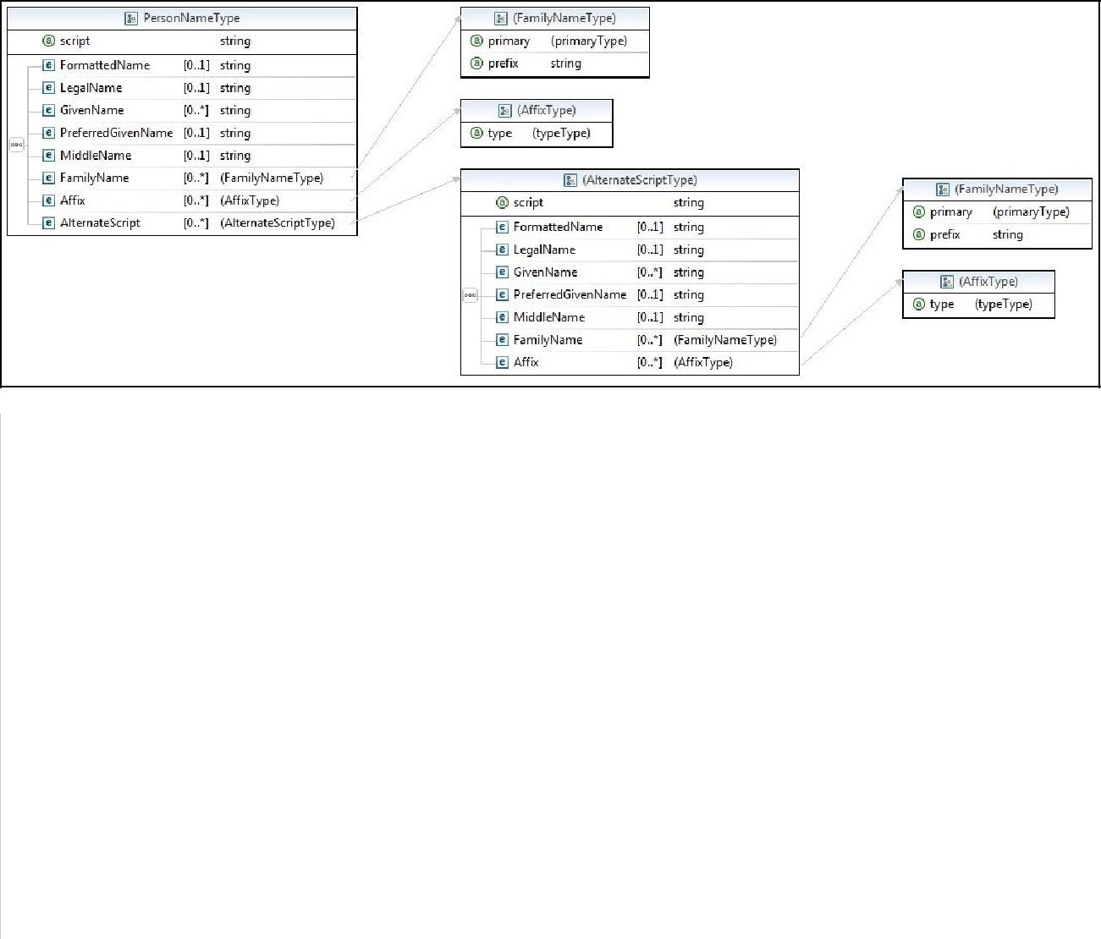

Element | Description | ADEP processing | Format
script |  | Ignored
FormattedName | Full name | Optional | 50 characters max.
 |  |  | This element is supplied by Adep, but
 |  |  | Adep does not take it into account at
 |  |  | receipt of an offer.
LegalName | Name in its | Optional | 50 characters max.
 | legal form |  | This element is supplied by Adep, but
 |  |  | Adep does not take it into account at
 |  |  | receipt of an offer.
GivenName |  | Ignored
PreferredGivenName |  | Ignored
MiddleName |  | Ignored
FamilyName | Family name
 |  | Ignored
FamilyName.primary | Primacy code | Ignored
prefix |  | Ignored
Affix | Civil status | Ignored
AlternateScript |  | Ignored


2. The PostalAddressType type

This type is derived from the HR-XML CPO standard. This is the appropriate structure for conveying postal addresses.
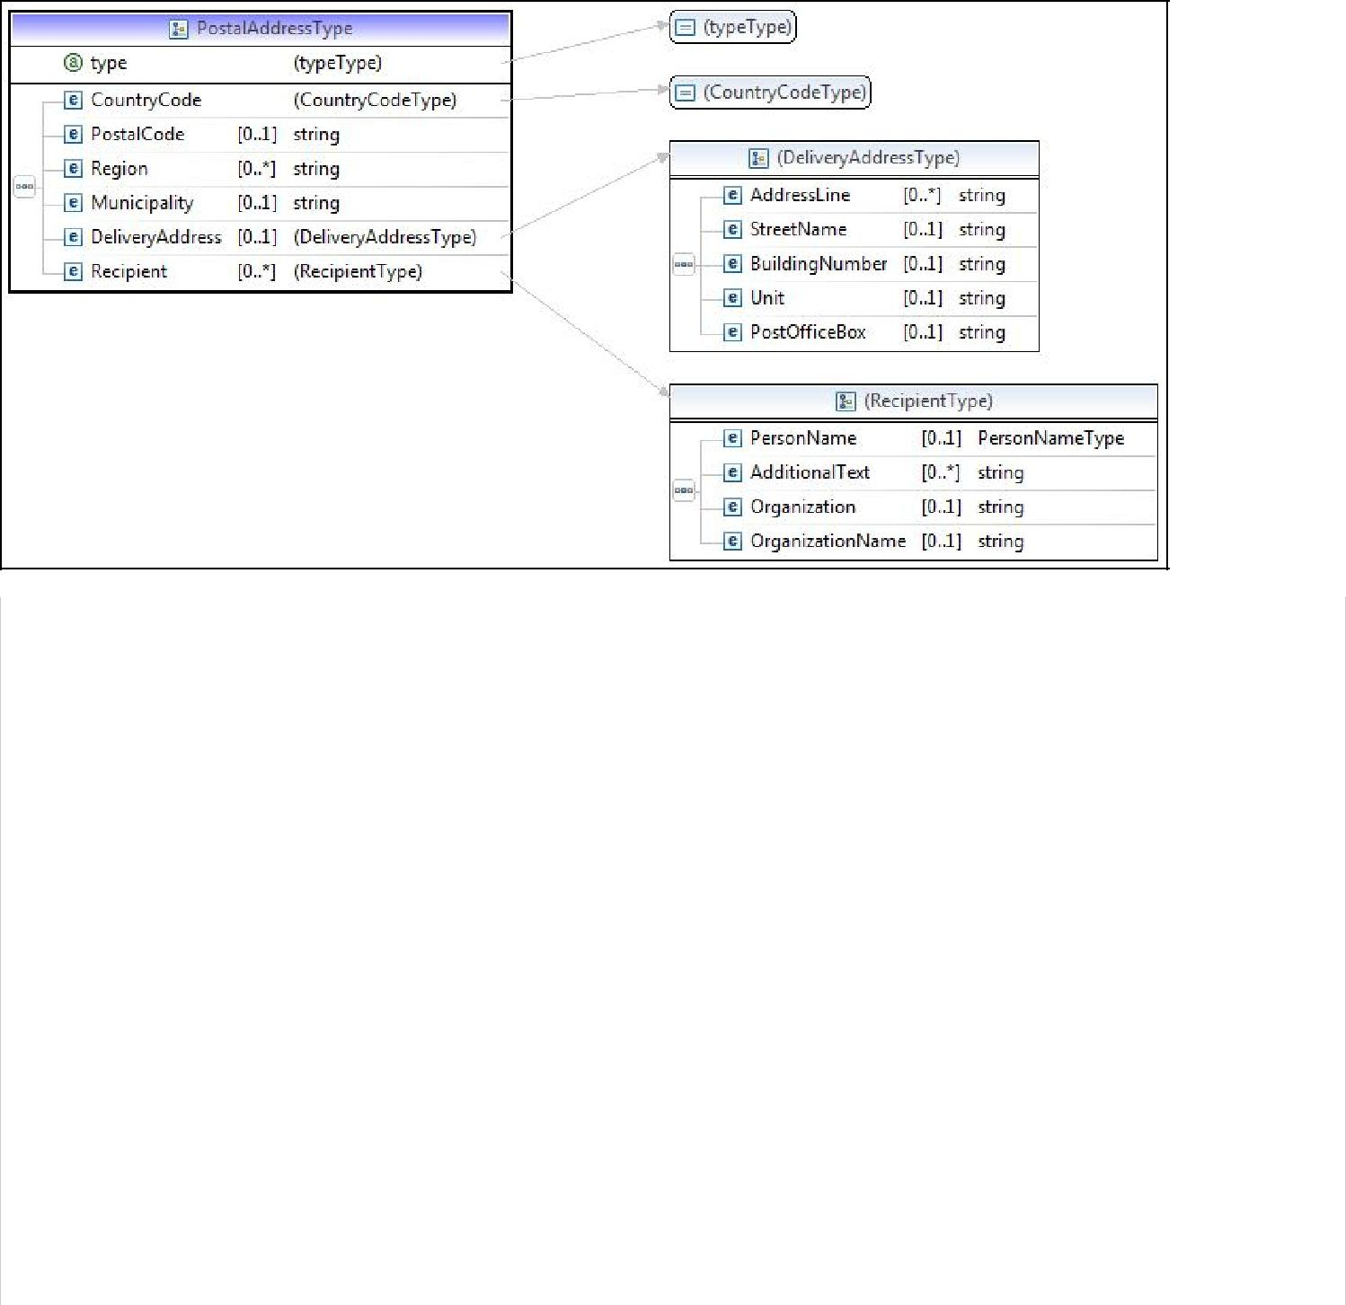

Element | Description | ADEP processing | Format
type |  | Ignored
CountryCode | Country | Ignored by ADEP
 |  | but
 |  | required by the
 |  | CPO standard
PostalCode | Postcode | Ignored
Region |  | Ignored
Municipality | City | Ignored
DeliveryAddress | Address of | Ignored
 | delivery
DeliveryAddress.AddressLine | 1st element: | Ignored
 | locality
 | 2nd element:
 | additional
 | address
DeliveryAddress.StreetName | Street name | Ignored
DeliveryAddress.BuildingNumber | Street
 | number
DeliveryAddress.Unit |  | Ignored
DeliveryAddress.PostOfficeBox |  | Ignored
Recipient |  | Ignored

3.The CompetencyType type

This type is derived from the HR-XML CPO standard. It is the appropriate structure for conveying specific skills requirements.
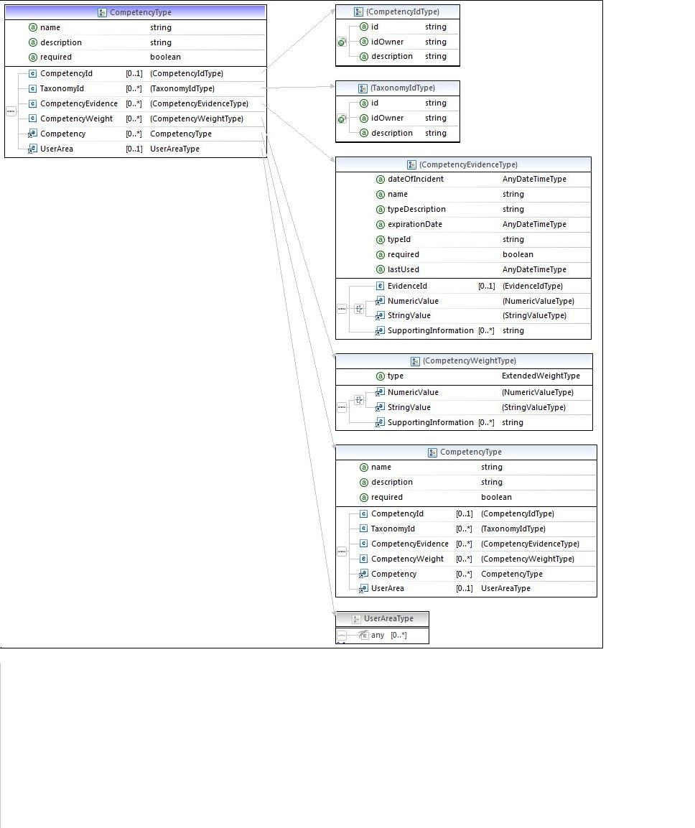

Element | Description | Processing | Format
 |  | ADEP
name |  | Mandatory | "GLOBAL EXPERIENCE LEVEL"
description |  | Ignored
required (Competency) |  | Ignored
CompetencyId | Identifying the | Ignored
 | competence
TaxonomyId | Agreement | Ignored
 | defining
 | identification
 | of the competence
CompetencyEvidence | Quantification of the | Mandatory | Experience level value
 | competence | only
 |  | for the
 |  | overall experience
 |  | level
CompetencyEvidence.dateOfIncident |  | Ignored
CompetencyEvidence.name |  | Ignored
CompetencyEvidence.typeDescription |  | Ignored
CompetencyEvidence.expirationDate |  | Ignored
CompetencyEvidence.typeId |  | Ignored
CompetencyEvidence.required |  | Ignored
CompetencyEvidence.lastUsed |  | Ignored
CompetencyEvidence.EvidenceId |  | Ignored
CompetencyEvidence.NumericValue |  | Ignored
CompetencyEvidence.StringValue |  | Mandatory | 1 character, must be from the domain
 |  |  | DOMAIN_EXPERIENCE_LEVEL
CompetencyEvidence.SupportingInformation | Contains the value | Ignored
 | of the competence
CompetencyWeight | Importance | Ignored
 | granted
 | to the competence
Competency | Recursive | Ignored
 | structure
UserArea |  | Ignored


4. The OrganizationType type

This type is derived from the HR-XML CPO standard. This is the appropriate structure for conveying information about an organization (company).

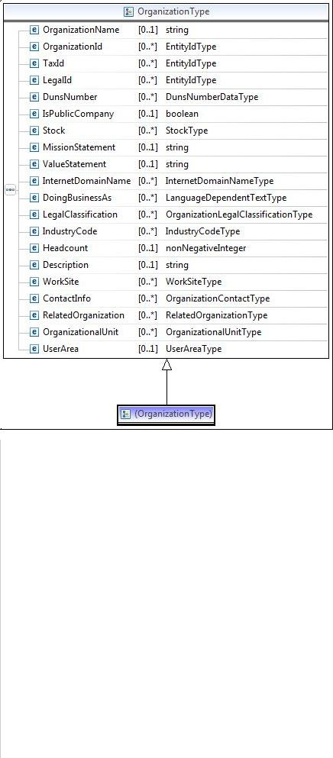

Element | Description | ADEP processing | Format
OrganizationName | Company name | Mandatory in case of | 38 characters max.
 |  | indirect client
OrganizationId |  | Ignored
TaxId |  | Ignored
LegalId | SIRET number | Mandatory for indirect clients, | 14 characters
 |  | only one element allowed
DunsNumber |  | Ignored
IsPublicCompany |  | Ignored
Stock |  | Ignored
MissionStatement |  | Ignored
ValueStatement |  | Ignored
InternetDomainName |  | Ignored
DoingBusinessAs |  | Ignored
LegalClassification |  | Ignored
IndustryCode | Company NAF code | Mandatory for indirect clients, | see 4.2 below
 |  | only one element allowed
HeadCount |  | Ignored
Description |  | Ignored
WorkSite |  | Ignored
ContactInfo |  | Ignored
RelatedOrganization |  | Ignored
OrganizationalUnit |  | Ignored
UserArea |  | Ignored


4.1 ContactInfo element

This element stores information about the contact within the actual client company.
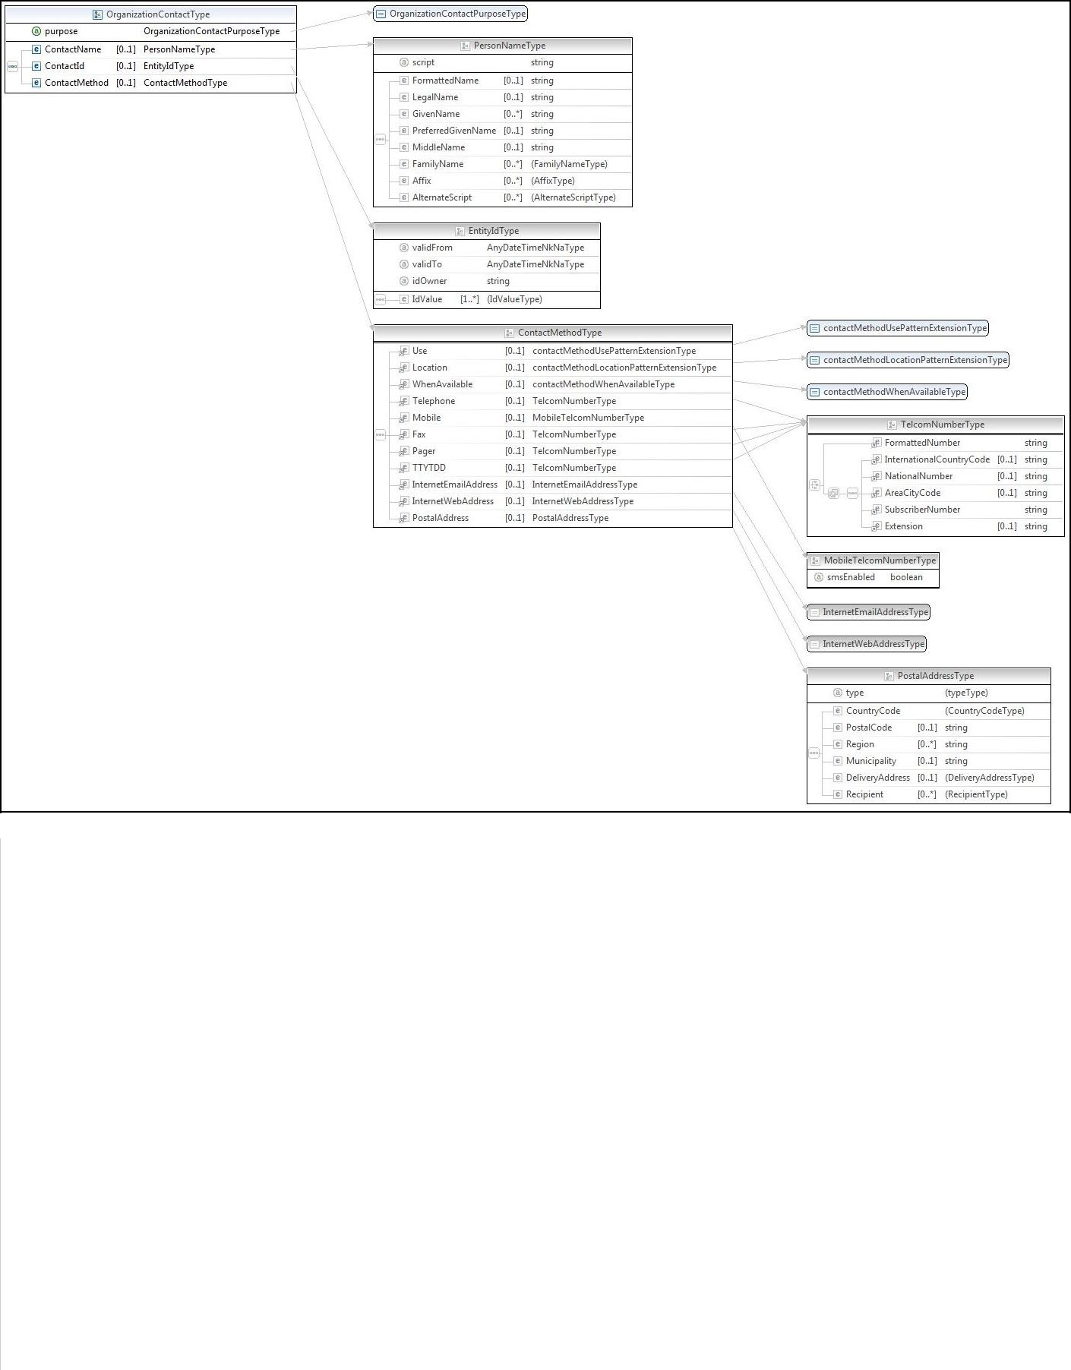

Element | Description | ADEP processing | Format
purpose |  | Ignored
ContactName |  | Ignored | See 1 below
ContactId |  | Ignored
ContactMethod | Contact methods | Ignored
Use |  | Ignored
Location |  | Ignored
WhenAvailable |  | Ignored
Telephone | Landline telephone | Ignored

Telephone.FormattedNumber | Landline telephone (complete) | Ignored
InternationalCountryCode |  | Ignored
(Telephone)
NationalNumber (Telephone) |  | Ignored
AreaCityCode (Telephone) |  | Ignored
SubscriberNumber (Telephone) |  | Ignored
Extension (Telephone) |  | Ignored
Mobile |  | Ignored
Fax |  | Ignored
Fax.FormattedNumber | Fax (complete) | Ignored
InternationalCountryCode |  | Ignored
(Fax)
NationalNumber (Fax) |  | Ignored
AreaCityCode (Fax) |  | Ignored
SubscriberNumber (Fax) |  | Ignored
Extention (Fax) |  | Ignored
Pager |  | Ignored
TTYDD |  | Ignored
ContactMethod.InternetEmail-Address |  | Mandatory in case of | 120 characters max.
 |  | indirect client
InternetWebAddress |  | Ignored
PostalAddress | Postal address


4.2 IndustryCode element

This element is mandatory and designates the NAF code of the actual company issuing the offer.

Only one element is taken into account by ADEP, identified by the value of the classificationName attribute. The value of this element must be taken from the INSEE standard "NAF ver. 2, 2008".

Element | Description | ADEP processing | Format
IndustryCode | NAF code | Mandatory | 5 characters max
primaryIndicator |  | Ignored
classificationName | Name of the organization | Mandatory if IndustryCode is supplied | "INSEE
 | defining this agreement

5 OpenPositionResponseType element

This type contains a list of elements of type OnePositionType.

5.1 OnePositionType element

Element | Description | Format
ApecPositionNumero | Apec offer number | String
clinetPositionId | Client reference | String
status | Current status of the offer | String

idValue or idOwner
If empty ==> ISO 3166 (version 2007)
Otherwise INSEE: URL to INSEE (country + municipality

6 EducationType element

Element | Descriptif | Format
EducationLevel | Le niveau d’étude demandé dans l’offre | String

XIII. Internship Offer
To create an internship offer, you must first update the XML feed sent in the request:

1. Contract Type
For an internship offer, set the contract type to 9 in userArea.jobType:
<UserArea>
<ns2:StatusJob>STAGE</ns2:StatusJob>
<ns2:Duration>6</ns2:Duration>
<ns2:JobType>9</ns2:JobType>
</UserArea>

2. Education Level
Add a new element for the education level in an internship offer. This element is filled using the tag:
<Education>
<EducationLevel></EducationLevel>
</Education>

Its values are defined by the domain NIVEAU_ETUDE_DOMAIN.
For SIDES, this data should be included in the PositionRequirements tag as follows:
<PositionRequirements interviewRequired="false" resumeRequired="false">
<Education>
<EducationLevel>4</EducationLevel>
</Education>
</PositionRequirements>

And in SEP, within the PositionDetail tag:
<ns3:PositionDetail>
<ns3:Education>
<ns3:EducationLevel>4</ns3:EducationLevel>
</ns3:Education>
</ns3:PositionDetail>

3. Job Type
Add a new value INTERNSHIP in the UserArea.StatusJob tag. This data is not mandatory in the request feed for creating an internship offer because it will be initialized upon receipt of the feed; Therefore, even if received empty, it will never be saved as empty and will go through a default initialization.
<ns3:UserArea>
<ns2:StatusJob>STAGE</ns2:StatusJob>
</ns3:UserArea>

4. Displayed Pay
The displayed pay is mandatory for an internship offer and must take one of the values from the SALAIRE_TEXTE_DOMAIN.
ADEP code | Label
4 | X € net mensuel
5 | Minimum légal
6 | Non renseignée

Reminder: the displayed pay is set in the UserArea.DisplayedPay tag.

5. Experience Level
This element becomes optional for an internship offer because it is initialized by default as NO_EXPERIENCE_REQUIRED.

6. Minimum Salary
This data is mandatory only if the displayed pay (DisplayedPay) equals 4 (X € net per month) and must be between 1 and 9999. Otherwise, it is optional.

7. Maximum Salary
The maximum salary is no longer mandatory for an internship offer, and its value is initialized by default to the minimum salary.

8. Offer Type
This data (POSITION_TYPE) is not mandatory and will default to ODD = DIRECT CLIENT REMOTE OFFER.

9. Contract Duration
Contract duration is mandatory for an internship offer and must be between 0 and 6:
ADEP Code | Label
0 | < 1 mois
1 | 1 mois
2 | 2 mois
3 | 3 mois
4 | 4 mois
5 | 5 mois
6 | 6 mois

